FORCAS/INVESTIGATION REPORT #1

Lightning strike demolishes two classrooms at the Kyugama Orphans Primary School in South Kivu, DR Congo.

By Bukuru Ruturaga Byamungu

Saturday, March 12, 2022
At 5:35 pm

Lightning struck and destroyed three trees at Kyugama Orphans Primary School, demolished two classrooms and took away their roofs.

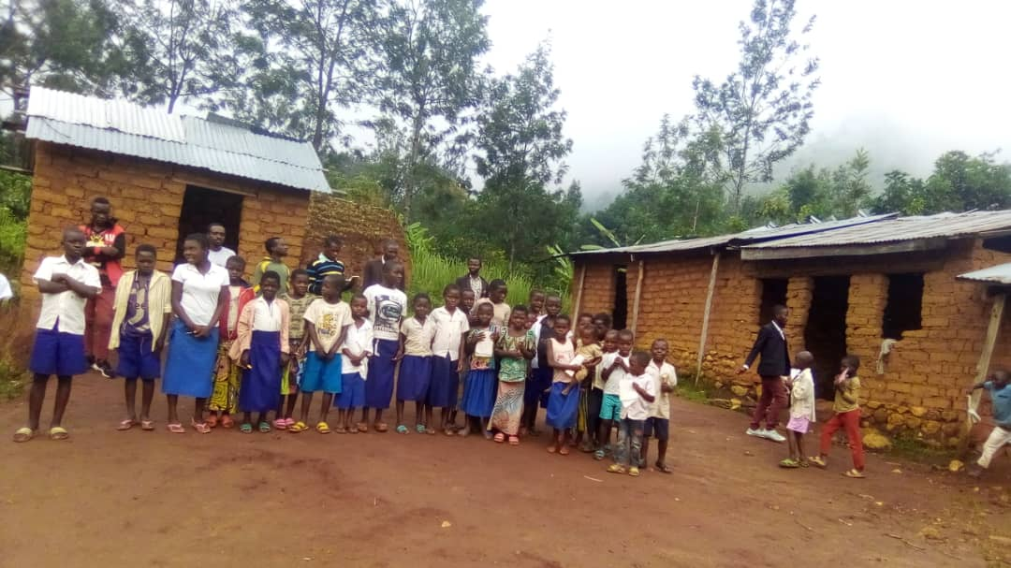

Until today the students - orphans, have not yet found another place to study! That's why we are calling for help and assistance to protect these orphaned and destitute children of the VB school. All the time in this village, the lightning makes a lot of material damage.

Byamungu Shonda Migani, Citizen Reporter.

