BULAMBULI: Lightning Kills Mother, Two Month Old Daughter – Uganda

https://eastnews.co.ug/2024/03/26/bulambuli-lightning-kills-mother-two-month-old-daughter/

Omagor Markson12 hours ago

24 March 2024

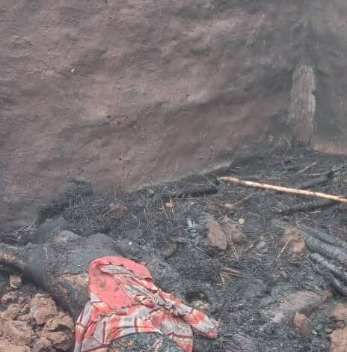
The house that was hit by lightning in Bulambuli
By Abubakar Bin Siraji

BULAMBULI

22 year old Ketty Mutuwa and her two month old daughter have been struck dead by lightning in Bumwalye village, Bushangi parish in Bwikhonge Sub County, Bulambuli district.

The duo was struck dead on Sunday afternoon 24th/03/2024 while in a grass thatched house, which also caught fire after the lightening.

Tom Mayeku, the sub county chief of Bwikhonge says that he heard a big blast at about 3.00 pm on Sunday and he went up to the scene only to notice flames from Ketty’s house.

Mayeku says that he saw the burning house only to notice the lifeless bodies of a mother and daughter lying on the ground, which confirmed his suspicion that they had been struck dead by lightning.

Ruth Namataka, a resident in the area says that her hut was also partly torched after the lightning strike, but she survived with injuries all over her body and she is currently receiving treatment at a private clinic in the area.

Namataka says their area has been experiencing lightning strikes, with registered fatal cases in recent days. She pleaded with government to purchase lightning conductors and install them at selected points in the area, so as to safeguard communities from suffering under such unpredictable strikes.

Erisa Masaba, another resident, says that the only Bwikhonge sub county headquarters in their area lacks a lightning conductor, which jeopardizes the safety of residents in situations where rains are consistent, characterized with lightning strikes and hailstorms.

Meanwhile, the L.C.3 chairperson of Bwikhonge sub county, John Matingo, confirms the incident, adding that they are in touch with responsible government entities and development partners to ensure installation of lightning conductors in risky areas.

