LBS broadcasts interrupted by lightning strikes [Liberia]
15 June 2020
https://thenewdawnliberia.com/lbs-broadcasts-interrupted-by-lightning-strikes/
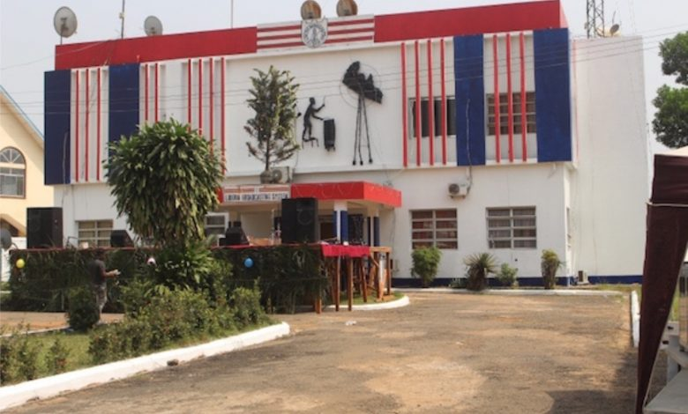
Spread the love
The Management of the Liberia Broadcasting System informs the Public that both ELBC Radio and the Liberia National Television, (LNTV) Services are experiencing major technical problems due to constant lightning strikes on these broadcast facilities. Also affected by the lightning strike is the transmission system of Radio France International (RFI).
The LBS Management says due to the level of damage done to these technical installations, the LNTV is now off and will remain so until the necessary replacement equipment damaged by the lightning are ordered from overseas and brought to the country for installation. This will take several weeks.
For ELBC Radio, LBS Management says, while the technicians have managed to painstakingly restore the broadcast, there are still critical technical issues with the radio transmission and production systems that have to be addressed before it is completely revived.
The complete functionality of these systems can only be done when the needed spares and equipment are procured and installed. It is therefore working with Central Government to secure needed funding to have these technical issues fully addressed in the coming weeks.
LBS Management therefore implores the listening and viewing public to exercise due understanding as all is being done to restore the system quality transmission on radio and television. Meanwhile, works to have RFI rebroadcast resumed is continuing with the arrival of the needed spares.

