**Lagos govt seals off three-storey building struck down by lightning**

**Nigeria.**

April 23, 2023

<https://gazettengr.com/lagos-govt-seals-off-three-storey-building-struck-down-by-lightning/>

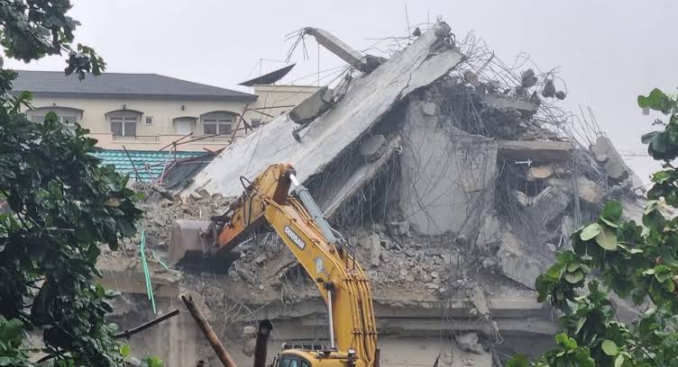

Lagos State Building Control building Agency on Sunday sealed an uncompleted three-storey building that collapsed in the GRA Apapa area of the state.

The building, located on no 45, Ladipo Oluwo Street, collapsed after being struck by lightning due to heavy rains.

Fortunately, workers were on holiday.

A statement issued on Sunday by the spokesperson of LASBCA, Mukaila Sanusi, stated that the developer “ignored the stop work and seal up orders” by the agency and continued the project.

The agency said no casualty was recorded upon site investigation on Sunday while the site has been cordoned off.

“This particular incident, like similar others, reinforces governments repeated calls for responsible behaviour on the part of all stakeholders in the built environment.

“Lagos State Government has immediately activated inquires into the collapse to unravel the minute details and guide appropriate actions,” parts of the statement read.

Barely one month ago, a seven-storey building collapsed in Banana Island, Ikoyi. The agency said no approval was issued for the [construction](https://gazettengr.com/multi-storey-building-collapses-in-banana-island/) of the building.