Stephane Schmitt, French Citizen Reporter and newsletter translator (French)

Hero of the Month for 2023-03

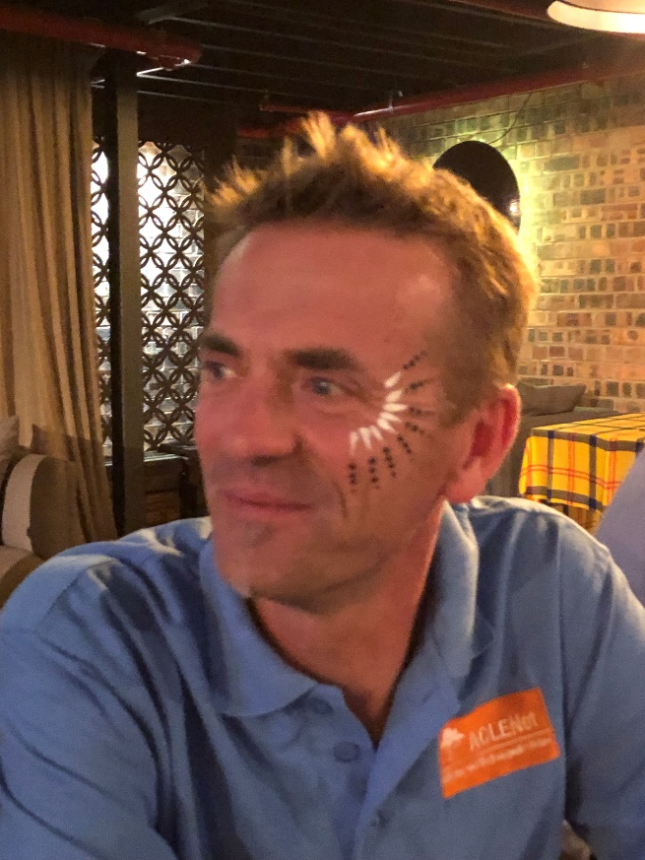

A. What is your background?
I have a multidisciplinary background which has led me to be interested in both the scientific and technical aspects of lightning, and its economic and social consequences

B. How and when did you hear about ACLENet?
I would say at an ILDC (International lightning detection conference)...probably in 2016

C. What motivated you to work with ACLENet?
The help, however small, that I can give to an NGO with a noble mission...which is moreover in my field of expertise

D. Please describe your work with ACLENet.
I am a "citizen reporter" and collect cases of lightning related incidents in the French-speaking media in Africa for ACLENet and sometimes analyze them. I also translate the monthly newsletter into French

E. What are your main achievements with ACLENet so far?
I am happy to have been able to organize a webinar for ILSD 2021 with the participation of people from 32 countries around the world.

F. What are some of the challenges you have encountered in your work with ACLENet? How have you overcome these challenges?
I am trying to figure out how to set up effective thunderstorm warning systems for people and am still working on it...Let's talk about it in the hopefully near future ;-)

G. How would you like to see ACLENet develop in the future?
By continuing its role as a pioneer that has created emulators (SALNET for example), while managing to coordinate the various actions to have more "weight".

H. What do you see in the future for ACLENet in terms of lightning safety?
Helping to set up thunderstorm warning system to improve safety in some areas

