Hero of the Month
2024-6

Gopa Kimar

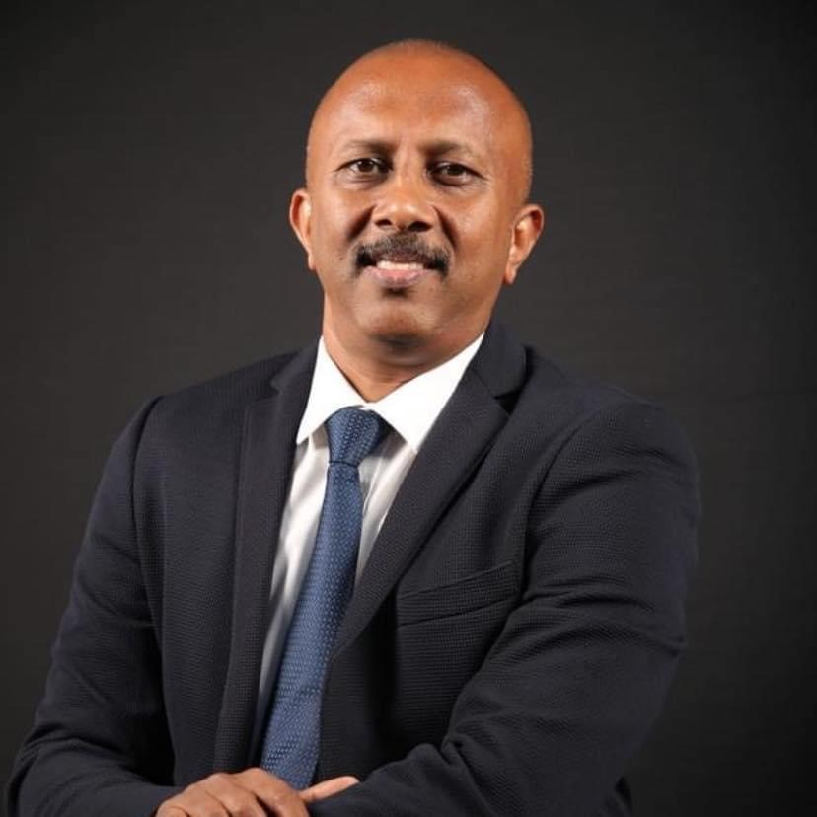

S. Gopa Kumar is an Electrical engineer, managing director of cape electric. He is having more than 25 years’ experience in Lightning protection, EMI/EMC of electrical installation, earthing and safety. Conducted more than 1000 site studies on failure in electronic equipment and electrical faults.

He has been actively organizing various safety awareness programs throughout India for the last 20 years. He was actively organizing lightning awareness programs in Kerala through CISSA-LARC. During April 2020, the state Disaster Management Authority claimed that the number of deaths in Kerala reduced to <4 due to a large scale of awareness on the subject in Kerala.

He is a member in the working groups of the following Indian and IEC technical committees and the technical coordinator of Lightning awareness and research center (LARC), Trivandrum.

IEC - TC64: (IEC 60364)
TC81: (IEC 62305)
SC 37 A: (IEC 61643)
BIS - ETD 20 (National Electrical Code, IS732, IS3043, IS/IEC 62305) & ETD 30
National Building Code-2016 (electrical committee),

He has published articles about safety in various magazines and published the book, THE MISSING LINK in the subject of electrical safety.

Contacts

Mob: +919962522244
E mail: gopa0904@gmail.com

