Report: 150 Yemenis killed, injured by lightning strikes since January - Yemen
August 10, 2023 at 12:29 pm | Published in: Middle East, News, Yemen Middle East Montor
https://www.middleeastmonitor.com/20230810-report-150-yemenis-killed-injured-by-lightning-strikes-since-january/
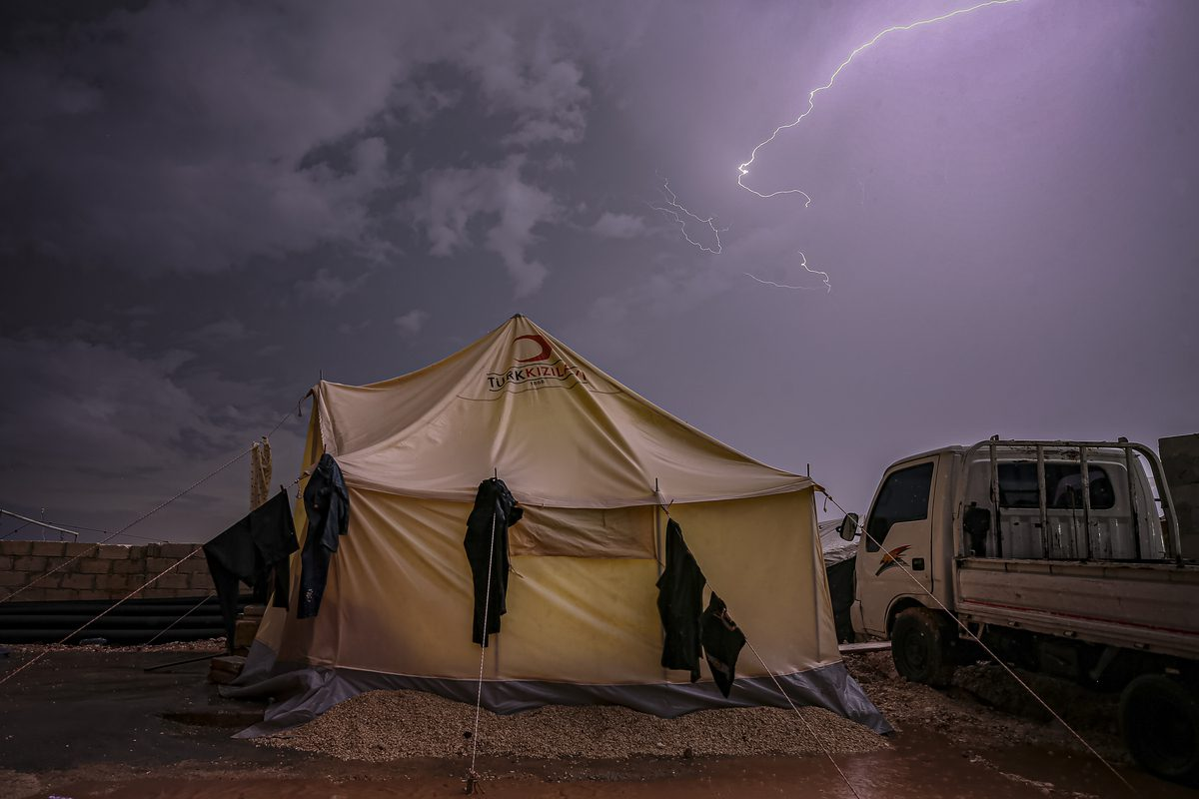
Lightning illuminates the night sky over Idlib, Syria on October 20, 2022 [Muhammed Said - Anadolu Agency]
August 10, 2023 at 12:29 pm
A total of 150 people have been killed or injured in Yemen from lightning strikes since the beginning of the year, Anadolu reported citing the Yemeni Red Crescent Society.
The humanitarian organisation published the figures in a brief statement in addition to educational guidelines aimed at "reducing the chance of exposure to lightning strikes".
Three people have recently been killed by lightning in the Houthi-held Saada governorate, in northern Yemen.
Lightning is common during the rainy season in Yemen which starts in mid-March.
Last Wednesday, the United Nations Population Fund announced in a report that more than 80,000 Yemenis have been affected by torrential rains since the beginning of the year.

