Lightning strike kills 3 people in Ogun State, Nigeria (graphic photos)
by Laila Ijeoma. July 13, 2018, 6:38 am
https://lailasnews.com/lightning-strike-kills-3-people-in-ogun-state-graphic-photos/
The incident occurred at Otunba Dipo Dina International Stadium road in Ijebu-Ode at about 3 pm during the downpour, according to eyewitnesses the fourth person had disembarked from the motorcycles they were riding on and ran towards a makeshift shelter for the rains to subside when tragedy struck
A lightning strike which came as a result of a heavy downpour in Ijebu-Ode area of Ogun State on Thursday, reportedly struck three men suspected to be in their early twenties dead.
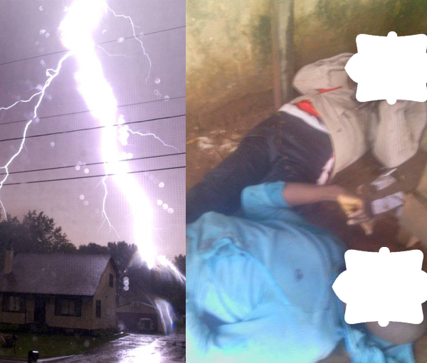
The incident occurred at Otunba Dipo Dina International Stadium road in Ijebu-Ode at about 3 pm during the downpour, according to eyewitnesses the fourth person had disembarked from the motorcycles they were riding on and ran towards a makeshift shelter for the rains to subside when tragedy struck.
NAN who shared photos of the late victims of the lightning strike, added that the fourth person took to his heels unharmed. The bystanders also refrained from going near the corpses for fear that the occurrence was related to perceived retribution from Sango, believed among the Yoruba to be the god of thunder.
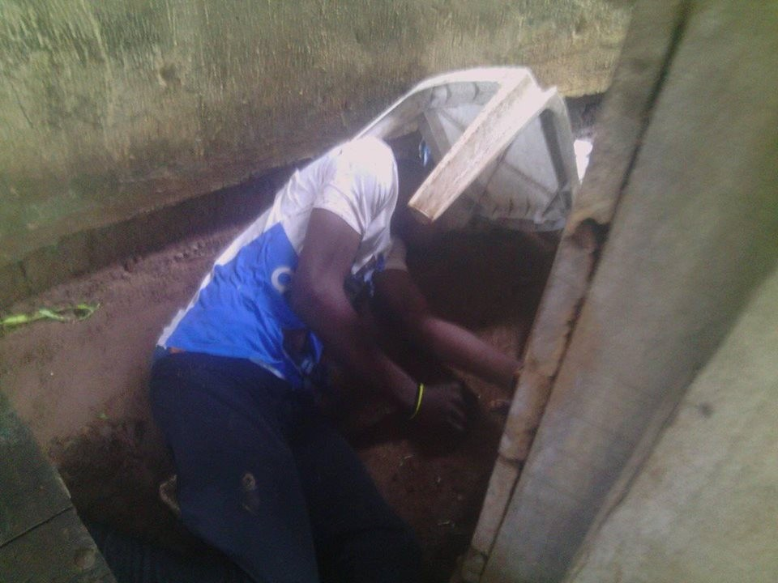
An eye witness, who claimed anonymity, told NAN that the people believe that anyone who died as a result of lightening was linked to punishment for wrong doing.
“No one can touch or remove their bodies until after some traditional rites to appease Sango are done,” the witness said.
It was also gathered that the police personnel who visited the scene, also refrained from moving near the corpses as they mounted a perimeter fence at the scene.
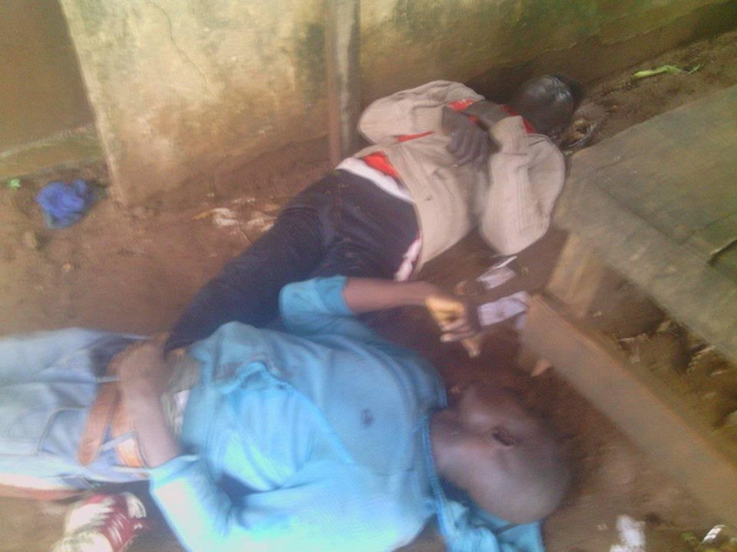
This is coming barely a week after a student of Ojukwu University was also killed by a lightning strike in his room. An eye witness who pleaded anonymity said the victim was struck dead following a downpour on campus at about 5pm on Monday.
He added, “He was a student of Agriculture Extension. He was going to his lodge at Achalla around 5pm when the incident happened.
It was gathered that the deceased was working his phone when the lightning struck. The Police Public Relations Officer in the State, Mohammed Haruna, confirmed the incident. Haruna said that Police detectives attached to Achalla division immediately rushed Vincent to a hospital where he was confirmed dead by a medical doctor. He said the boy’s parents were contacted immediately.
“They have since conveyed the corpse to their village in Aguleri for burial,” Haruna added.

