Secondary school lightning victims identified (Zimbabwe)
by Staff Reporter
28 Jan 2017 at 05:49hrs | 1102 Views
https://bulawayo24.com/index-id-news-sc-national-byo-103285.html

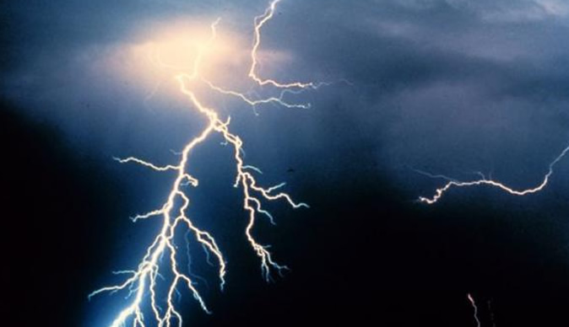

Police have identified the two students that were struck by lightning at Chinatsa Secondary School in Macheke yesterday.
Grief has also gripped the community following the incident that left a trail of destruction and ploughed the ground for over 200m surprisingly with not a single drop of rain falling.
Police confirmed the two students who fell victim are Munashe Godknows a form two student aged 15 of plot 23 village 18 Wenimbe and Blessed Muchenga a form 4 student aged 17 of plot 24 village 4 Wenimbe.
The number of those injured has also risen to 83 with 57 having been treated and discharged at both Marondera Provincial Hospital and Wenimbe Clinic while 26 are admitted at Marondera Provincial Hospital.
Hours after the incident a sombre atmosphere engulfed the school vicinity with no students having turned up for school this Friday (today) while visibly shocked villagers were trickling in hoping to find some explanation.
An inspection of the area showed no rains fell despite the lightning bolt ploughing a distance of 200m in the school yard.
Burnt school uniforms, satchels and torn shoes belonging to the students have been gathered and kept in the school office.
Meanwhile relatives, friends and church members have also started gathering for the funeral of Blessed Muchenga at the Shekede homestead in village 4 just 100m from the school.
It is an occurrence that has shaken the entire community in Macheke and one hopes there will be counselling for the many traumatised children.

