MALAWIAN TEENAGE LOVERS DIE AFTER LIGHTNING STRIKE
January 17, 2018
http://www.zambianobserver.com/malawian-teenage-lovers-die-after-lightning-strike/
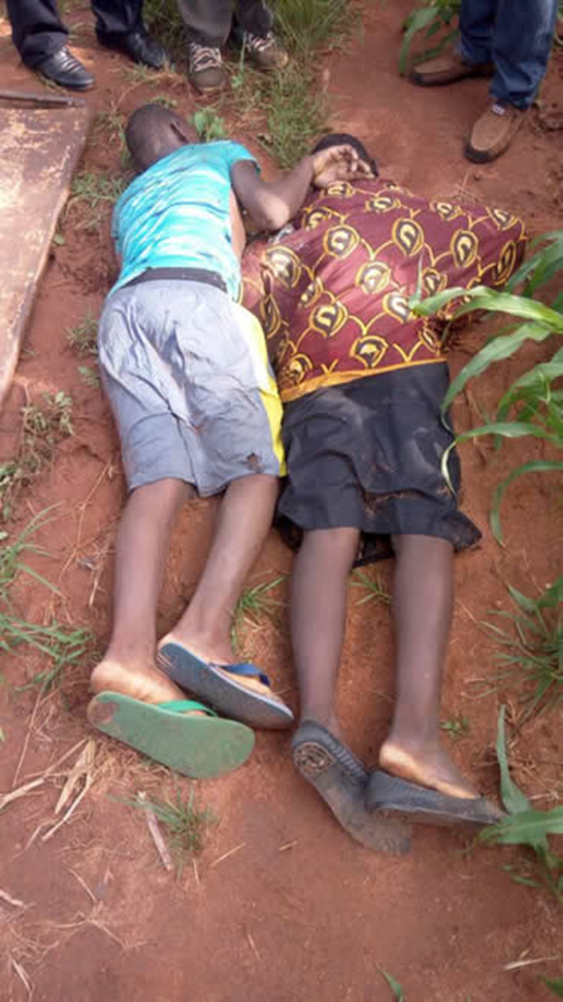
LILONGWE – Two teenagers in a love affair were on Monday struck and killed by lightning in Lilongwe at around 18:00 hours.
Kanengo Police Public Relations Officer, Laban Makalani, confirmed the incident to Malawi News Agency (Mana) on Tuesday in an interview.
He said the incident occurred at Mzondo Kachimbwinda Village (near Dzenza) in the area of Traditional Authority (TA) Chitukula of Lilongwe District.
Makalani identified the deceased as Patricia Guwe, 12, of Mzondo Kachimbwinda Village, T.A. Chitukula, Lilongwe and Anderson Yohane, 16, of the same particulars.
Malakani said the deceased were in a love affair and were chatting in a maize field when a thunderstorm occurred. He said on Tuesday morning they were found dead with signs of a lightning strike.
He said the parents of the teenagers reported the matter to police and officers visited the scene where they collected dead bodies to Kamuzu Central Hospital (KCH) for postmortem. The postmortem confirmed that death was caused by lightning.
Makalani said both of them were Standard 6 pupils at Dzenza Primary School.
Meanwhile, police have advised the general public that during thunderstorms any person outside the house should seek refuge in a car or grounded building when lightning or thunder begins.
He said if the person is caught outside away from a building or car, they should stay clear of water bodies and tall objects like trees. They should also find a low spot or depression and crouch down as low as possible, but should not lie down on the ground.
Makalani advised the public to avoid taking baths or shower when it is raining and not to wash dishes.
He further advised people to avoid using landline phones, televisions, and other appliances that conduct electricity.
Photo : The teen victims of lightning strike in Lilongwe on Monday – courtesy of Kanengo Police

