**Fatal lightning strikes hit Tshimbulu, southern DR Congo amid heavy rainfall**

Wednesday, April 19, 2023

<https://watchers.news/2023/04/19/fatal-lightning-strikes-hit-tshimbulu-southern-dr-congo-amid-heavy-rainfall/>

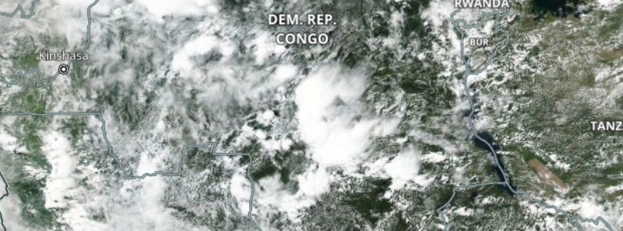

**Heavy rainfall and thunderstorms hit the southern Democratic Republic of the Congo, particularly Kasaï-Central Province**, **from April 15 to 17, 2023, causing casualties and property damage.**

As of April 19, media reports mention 8 fatalities and one heavily damaged house in the town of Tshimbulu, eastern Kasaï Central Province, due to lightning strikes that occurred on April 15 and 16.

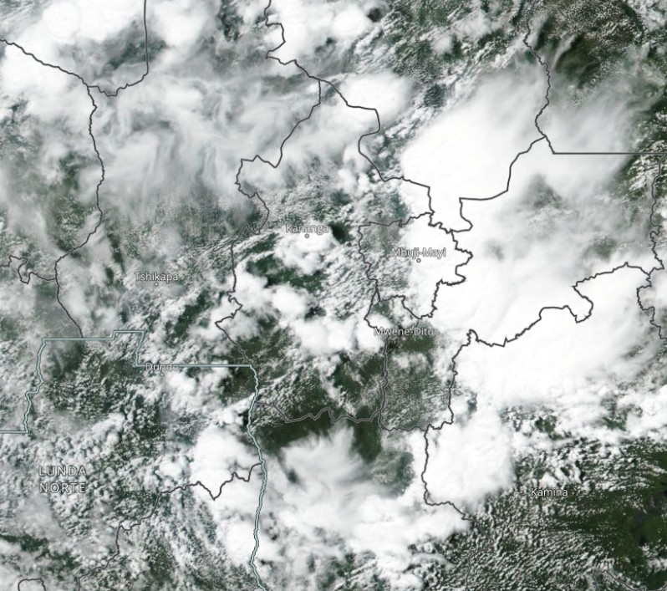

Over the next 24 hours, most of the country, including the already affected Kasaï-Central, is expected to face very heavy rainfall, exacerbating the situation in the region.

Kasaï-Central Province, located in the south-central part of the Democratic Republic of the Congo, experiences a tropical savanna climate. This type of climate is characterized by distinct wet and dry seasons, with relatively high temperatures throughout the year.

The wet season typically lasts from October to May, during which the region receives the majority of its annual rainfall. The dry season occurs between June and September and is marked by lower precipitation levels and higher temperatures. Average temperatures in the province range from around 20 °C (68 °F) to 30 °C (86 °F