**Busoga Kingdom, Church partner to curb lightning strikes in schools-Uganda**  
<https://www.monitor.co.ug/uganda/news/national/busoga-kingdom-church-partner-to-curb-lightning-strikes-in-schools-4705114>

28 July, 2024   
  
By  [Philip Wafula](https://www.monitor.co.ug/uganda/philip-wafula--1935934)   
Jinja Bureau Chief   
Monitor

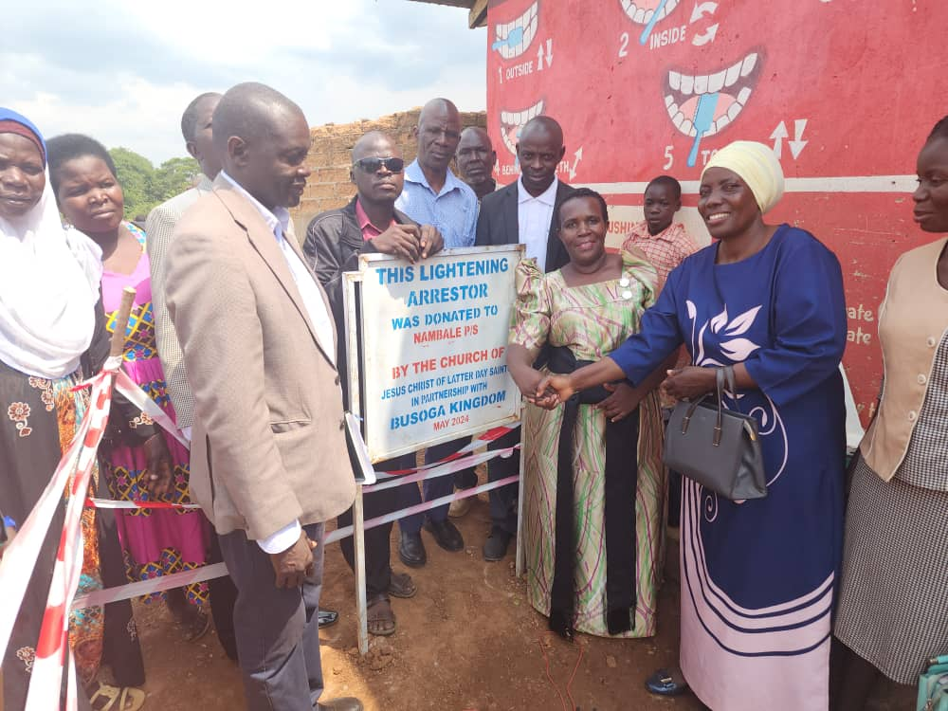

Busoga Kingdom and the Church of Jesus Christ of Latter Day Saints in Uganda have launched a project to curb lightning strikes in schools in the Sub-region free of charge.

The project, which was launched on Friday, will see the installation of lightning arrestors in 100 schools, thereby protecting over 100,000 students wherever they go to school, although most schools in the area still do not have arrestors.

Schools in Busoga Sub-region, like most parts of the country, have been prone to being struck by lightning which has left scores dead and others hospitalise

In June 2020, lightning struck dead two teachers and injured 15 pupils at Queen Zainab Primary School in Bugaya Sub-county, Buyende District, while earlier, in June 2011, two pupils at Nawangoma Primary School in Jinja District were struck to death by the thunderbolt.

Around the same time, four students at Valley Hill Secondary School in Kaliro District were hospitalised after being struck by lightning.

However, the latest incident, in February, in which Loy Kanage, a teacher at Nambale Primary School in Iganga District was struck dead by lightning, has seen the school, along with over 100 others, equipped with lightning arrestors to curb such strikes in future.

Busoga Kingdom Prime Minister, Dr Joseph Muvawala, expressed confidence in the partnership's potential to protect schools at high risk of lightning strikes.

“In both the Church’s structure and our Kingdom, the foundational principle is to serve humanity, making us strong allies with shared values as we strive to improve the living standards of our people,” Dr Muvawala, who is also the Executive Director National Planning Authority, said.

He added: “The projects we have implemented are successful and directly benefit our people. By providing a maternity ward with beds, we have created a comfortable environment for expectant mothers to safely deliver their babies with the assistance of trained professionals.”

Mr Godfrey Kitimbo, the Jinja Church Communications Director, emphasised the Church's commitment to community service.

“The services we provide are community-oriented. We stand with just causes that impact communities wherever necessary, and our support is comprehensive, regardless of the individual's religion, tribe, or political affiliation,” said Mr Kitimbo, adding that offering support to those in need is the most effective approach.

The collaboration has enabled the Church to provide food supplies, agricultural tools, and support for constructing well-equipped maternity wards and classroom blocks. These efforts have also contributed to improved food security and a reduction in sexual and gender-based violence within households.

To date, over 50,000 individuals have benefited from previous projects, and many more are expected to gain from this ongoing partnership, which has positioned Busoga Kingdom as home to the largest number of Latter-day Saints Churches in Uganda.