**Lightning strike kills Midlands State University student (Zimbabwe)**

By [Muza Mpofu](https://www.myzimbabwe.co.zw/videos-pics/15721-lightning-strike-kills-midlands-state-university-student-see-photo.html)

1 February 2018

<https://www.myzimbabwe.co.zw/videos-pics/15721-lightning-strike-kills-midlands-state-university-student-see-photo.html>

In a suspected case of juju, a Midlands State University student died on the spot yesterday when lightning struck her at Chegutu Hospital. Only identified as Thelma, the victim was a third-year student on attachment studying towards a degree in Biotech Engineering.

A source who spoke to this reporter on condition of anonymity said he was visiting a patient when it happened.

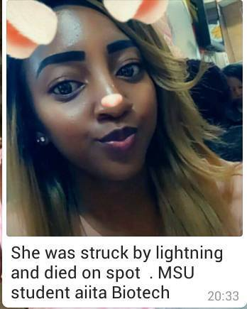

“Yaah I was at Chegutu hospital today on a patient visit.

“The lightning was too much ndazongoona vanhu vakumhanya vachiti panevanhu varohwa nemheni kuseri kweward apa ndangandiri muward (The lightning was too much I just saw people running around crying out that there were people hit by lightning behind the ward where I was),”said the source.

The source explained that the deceased had her phone in her bra when it happened.

“The thing is they were said to be holding their phones when the lightning struck and the other one had hers in her bra. I think she is the one who died on the spot because it struck on her chest destroying the phone.)

“Umwe wacho apiswa hembe ikabvaruka, paauya akatakurwa Ropa ranga richibuda mumuromo,,,but I did not manage to get their names coz that moment mheni yabva yadzokorodza kupenya zviri serious and everyone was terrified shouting dzimai maphone! Haa ma1 (The other one had her clothes burnt and tattered and she was bleeding from the mouth but I did not manage to get their names at the moment because the lightning struck again fiercely and everyone was shouting asking us to switch our phones off.)

– Kudakwashe Pembere