Wednesday, 21 February 2018

**Source:** classfmonline.com

2018-02-21

**Lightning kills one, 200 injured after downpour (Ghana)**

https://www.ghanaweb.com/GhanaHomePage/NewsArchive/Lightning-kills-one-200-injured-after-downpour-628020

[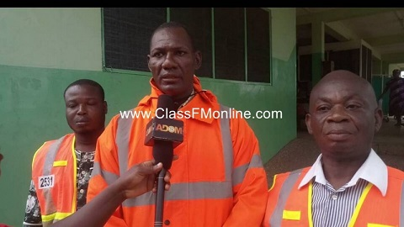](https://www.ghanaweb.com/GhanaHomePage/NewsArchive/Lightning-kills-one-200-injured-after-downpour-628020?gallery=1)

One person is dead with hundreds wounded at Ngleshie Amanfrom near Kasoa in the Ga South Municipality following thunder and rainstorms that accompanied the heavy downpour on Tuesday, 20 February 2018.  
  
A lightning that struck during the rains killed a 38-year-old man and the storm ripped the roofs of a cluster of schools as well as some houses at Ngleshie Amanfrom.  
  
Accra FM’s Evans Darko reported that the sheets wounded scores of individuals.  
  
In other instances the roof caved-in and fell on some school children who were having lessons at the time.  
  
Several other individuals also sustained various degrees of injuries from flying tree branches and other items carried by the whirlwinds.  
  
The injured individuals were rushed to the Amanfrom Government Hospital for treatment after the rains while the corpse was deposited at the morgue of the facility in wait for the family of the deceased.  
  
Officials from the National Disaster Management Organisation (NADMO) were dispatched to the area to offer assistance to affected individuals.  
  
Deputy NADMO Coordinator for the Ga South Municipal Assembly, Wonder Matthew Jiaggey who spoke in an interview advised residents to take a cue from the accident and use quality materials for their buildings to withstand bad weather.