Uganda lightning strike kills 10 children playing football in Arua
https://news.yahoo.com/uganda-lightning-strike-kills-10-104437501.html
BBC•August 28, 2020
Ten children have been killed by lightning in the north-western Uganda city of Arua after sheltering in a hut during a storm.
The children were playing football when heavy rain forced them to take a break in a nearby grass-thatched structure which was struck by lightning.
Nine children, aged 13 to 15, were killed on the spot while another died on the way to hospital.
Three survivors are receiving treatment at the regional hospital.
Uganda's north-western region has been experiencing severe rains coupled with thunder and lightning.
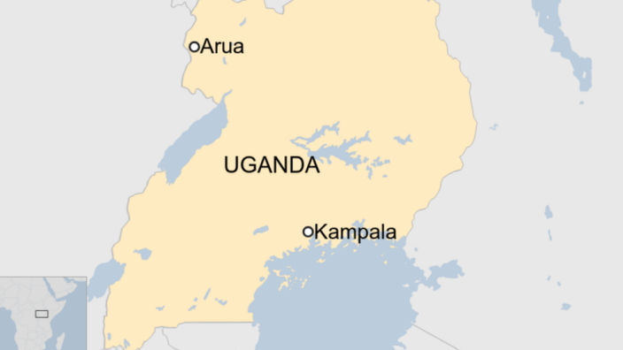
Map of Uganda showing Arua

This is the worst accident of its kind in Uganda since 2011, when 18 children were killed at a school in the mid-western region.
That year, 28 people also died from lightning strikes in a single week.
In February this year, four rare mountain gorillas were killed after being hit by lightning.

