**Pupils still hospitalised after lightning strike**

**Henry Nsubuga,** Journalist @New Vision, 21 May 2022

#Education#Lighting#Schools

<https://www.newvision.co.ug/articledetails/134468>

*EDUCATION | LIGHTNING | SCHOOLS*

32 pupils and three teachers at Kembo Nuuhu Primary School in Buvuma district, ended up being disastrous when lightning ...

Jennifer Nakizza, a teacher, said they were teaching at about 9:00am when it started raining, then suddenly lightning struck, leaving the whole school in shock.

BUVUUMA - **What began as a normal day for 32 pupils and three teachers at Kembo Nuuhu Primary School in Buvuma district on 17 May, ended up being disastrous when lightning struck the school.**

The strike left several pupils unconscious and some hospitalised.

The Buvuma district health educator, Muhammad Nviiri, said the incident happened at the school that neighbours Kembo landing site in Buvuma town council on Tuesday.

**The news**

Nviiri told *New Vision* that at about 9:30am, he received a phone call from one of the village health team members from the landing site, who informed him about the incident seeking their immediate intervention.

“On rushing to the scene, district chairperson Adrian Wasswa Ddungu and I found several children unconscious and the entire school community wailing. One of the three affected teachers was also unconscious,” he said.

**Pupils found in shrine**

Nviiri said they learnt that the pupils who were in critical condition had been taken to a traditional healer.

“We collected all the affected individuals and brought them to Buvuma Health Centre IV, where they received immediate medical attention,” he said.

**Two still admitted**

By press time, two pupils were still hospitalised, while the rest of the patients were discharged.

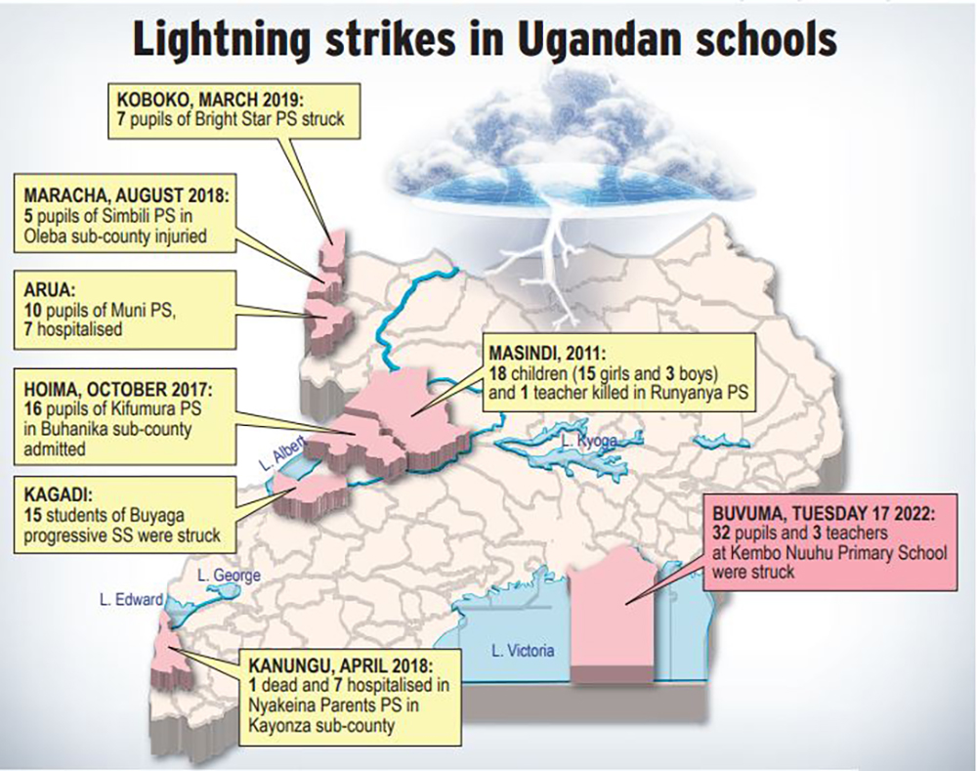

***Lightning strikes in Ugandan schools. (Graphics by Brian Sekamatte)***

The pupils are Rayan Ssempebwa (had not yet gained consciousness) and Joyce Namuzungu, who was recovering.

Racheal Nankabirwa, one of the nurses who responded to the emergency, said they received 32 pupils at the health facility, but due to a number of factors, including lack of hospital beds and space, they were forced to discharge the big number after showing signs of recovery.

“Apart from the lightning, the pupils were also affected by shock caused by the incident,” Nankabirwa said.

**Accounts of ordeal**

Jennifer Nakizza, a teacher, said they were teaching at about 9:00am when it started raining, then suddenly lightning struck, leaving the whole school in shock.

Shaina Namufumba, the Primary Two class teacher, said after the lightning struck, the frightened pupils ran to her.

She also saw five goats running into the classroom, but one of them died instantly at the doorway.

Bushira Aikoru, a Primary Two pupil, said she suddenly saw fire all over the classroom as the lesson was going on.

“Many of us felt the heat, got burnt and started crying. Some pupils managed to run towards the teacher who was seated in front, while others fell helpless on the classroom floor,” Aikoru said.

**Other strikes in schools**

In 2011, lightning struck Runyanya Primary School in Masindi district, killing 18 children (15 girls and three boys) and their teacher instantly.

In October 2017, 16 pupils of Kifumura Primary School in Buhanika sub-county, Hoima district, were admitted to hospital after lightning struck them.

In March 2019, seven pupils of Bright Star Primary School in Koboko municipality suffered shock after being struck by lightning Lightning struck 10 pupils of Muni Primary School, Arua during a heavy downpour. Seven of the victims were rushed to Arua Hospital.

**Previous strikes in Buvuma**

Muhamood Isire, the Kembo landing site chairperson, said this is the third time lightning is striking the landing site.

He said a couple of months ago, lightning struck near the same school and one of the trees dried up thereafter.

Isire asked well-wishers to help them with lightning arresters so as to avoid future incidents which could be even more dangerous.