**COUPLE FEARS LIGHTNING WILL STRUCK AGAIN [SOUTH AFRICA]**

By Mzamani Mathye

<https://www.dailysun.co.za/News/National/couple-fears-lightning-will-struck-again-20180116>

16 January 2018

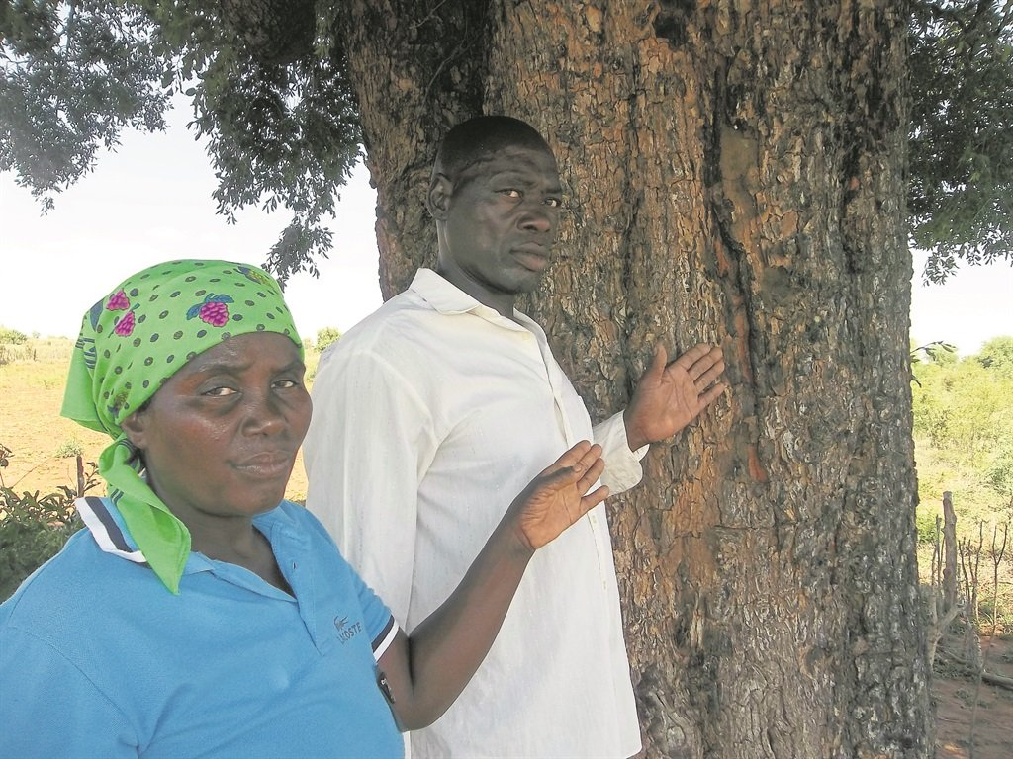

Khazamula Chauke and his wife Vukati were standing under this tree when the lightning struck. Photo by Mzamani Mathye .

A COUPLE from Makuleke Village in Limpopo are haunted by the sound of lightning striking their home.

This after their home was struck by lightning a week ago.

Khazamula Chauke (54) and his wife Vukati (48) were rushed to Malamulele Hospital after their ears, waists and legs were injured.

They spent a day in hospital before they were discharged.

Now they say they constantly hear horrible lightning sound and are living in fear.

Khazamula told*Daily Sun*: “My wife and me are still reeling in shock. Our nightmare is not yet over as we have become prisoners in our own bodies.

“Although we received counselling, the sound of that lightning continually fights with us in our minds.

“I still see a bolt of lightning hitting us under a tree. And I could feel my whole body going numb.”

He said he doesn’t know what to do to get out of his misery.

His wife Vukati appealed to any strong inyanga or prophet for help.

Nwa-xithlangoma Chauke (65), a traditional healer, said: “The couple need a strong sangoma who can give them muthi that will remove the bad luck and the bad dreams they are having.”

Nwa-xithlangoma said if they didn’t go through the process, they were likely to be hit by lightning again in the near future.