FORCAS/INVESTIGATION REPORT - DRC

Lightning kills a father, leaving a widow and 6 orphans alone, in Uvira District/South Kivu (LEMERA Groupment, KYUGAMA locality), on Sunday, March 20, 2022 at 12:30 pm.

By TAABU SIKILIZA

Lightning killed a 40-year-old man, identified as Filemon Rugereka, in the district of Uvira.

The incident occurred on Sunday, March 20, 2022 in Kyugama village, at home. Mr. Filemon Rugereka and me, his wife, were with our children. I was preparing food for them when the tragedy occurred. He died immediately and left me with six orphaned children (four boys and two girls).
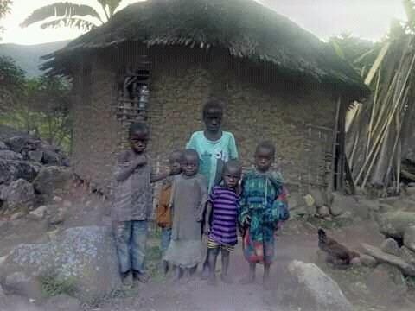
Filemon Rugereka was just a responsible person and took care of his family members.

We come with this nth case, to show you that in this village, lightning kills cattle and men, without mercy!

Reported by Mrs. TAABU SIKILIZA, widow and citizen reporter.

