Lightning strikes man (Malawi)
By Mphatso Khutcha Richard on Nov 27, 2016 Top News
https://malawi24.com/2016/11/27/lightning-strikes-man/
A man has been injured after he was struck by lightning which came with the heavy rains that fell in Blantyre city on Saturday.
The man whose particulars are not yet known was rushed to Queen Elizabeth Central Hospital for medical attention after well-wishers saw him struggling on the ground.
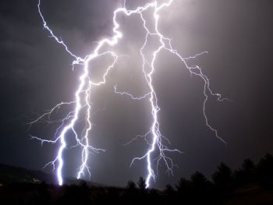According to eye witnesses who spoke with Malawi24, the man sought shelter in a shade which is opposite to Mbayani Assemblies of God, close to Mbayani primary school in Mbayani Township as he was waiting for the rains to end.
While in the shade, the man met his fate. The strong lightning struck at around 1 O’clock in the afternoon of the same day and left people around trembling with fear.

