Footballer fighting for his life in hospital after being struck by lightning (Kenya)
https://www.standardmedia.co.ke/sports/article/2001272087/footballer-fighting-for-his-life-in-hospital-after-being-struck-by-lightning
By Odero Charles Monday, March 5th 2018 at 19:30
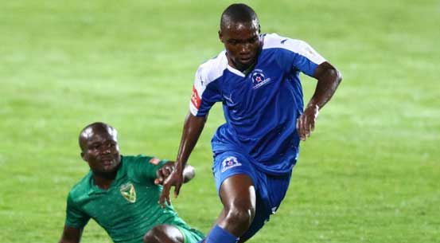
Maritzburg United's Luyanda Ntshangase
Maritzburg United striker Luyanda Ntshangase is fighting for his life in hospital after being struck by lightning during a friendly match in South Africa.
According to Maritzburg United coach Fadlu Davids, the 21-year-old is still in the intensive care unit (ICU) where he was placed in an induced coma.
"He is still in ICU. We are asking the whole football fraternity to please pray for him so he can make a speedy recovery," Club coach Fadlu Davids told Kick-off.com.
Ntshangase was knocked unconscious and had to be resuscitated by the club’s medics before being taken to hospital.
"I am extremely proud of the players considering the rollercoaster they went through after Ntshangase was struck by lightning.
"It's a huge situation we faced. We had to cancel the training session and I didn't know how to keep their emotions intact," Davids added.
ALSO READ: Former Kariobangi player swam with sharks in KPL before making Premier Soccer League move
Some players of the opposition team were also hurt but the injuries were considered minor.

