Ten Children Killed by Lightning during

Village Football Match

Richard Tushemereirwe
Executive Committee, ACLENet
Email: richadt2002@yahoo.com

Mary Ann Cooper, MD
Managing Director, ACLENet
Email: macooper@uic.edu

Abstract: On 28 August 2020, the press reported a major incident involving a relatively large number of deaths https://www.newvision.co.ug/news/1525795/arua-police-children-killed-lightning .

According to news reports, a game of football was going on at a pitch near Odramacaku trading center, a small town close to the border between Uganda and Democratic Republic of Congo (DRC), when it started raining. The children, who had been playing football in the open fields, took shelter in a nearby grass thatched hut. While in the hut, a bolt of lightning struck, instantly killing nine (9) children and shocking others. Another boy died on the way to hospital, the 10th. Only four were reported as survivors. ACLENet responded by sending a team to make detailed investigations through interviews and site inspection.
The team found distortion of facts in some instances by the press reports. It was also found that the survivors sustained injuries, physical and psychological, many with potential life-long medical difficulties. Additionally, the locals expressed spiritual connotations to the incident.
The locals also expressed discontent towards the Ugandan government’s response to the disaster which ACLENet hopes to share with the Ministry of Disaster Preparedness and Refugees.
Keywords: lightning, lightning injury, school, lightning safety, lightning injury prevention, lightning risk assessment, Village, lightning in Arua, Uganda.
- INTRODUCTION
Towards the end of August 2020, shocking news appeared in headlines in Uganda and internationally reporting ten children killed by a single lightning strike. The Uganda Police Force (UPF), Arua regional office, took a lead on this incident and issued a press statement naming the children who died as AS 16yo male, Awia Kennedy-13, Andama Godfrey-13, Bati Gasper-15, Afeku Saviour-13, Edema Jasiri-15, Ocatre Patrick-13, Asite Jordan-11, Apajobo David-12, and Tom-13.
UPF also confirmed the survivors as 11-year-old Ayikobua Martin from Nyaute village, 14-year-old Munguci Boniface also from Nyaute village, Adriko Yofasi, 14, from Gbuluku village, and Andama Festo - 9, from Gbuluku.
The police statement paid tribute to the young boys saying: "It’s a very unfortunate and sad incident’. This reflected the mood of the community near and around Odramacaku town.
After successful fundraising for an investigation, with co-operation from UPF in Arua regional office, ACLENet dispatched a team to the incident with two main objectives:
- Reconstruct the lightning incident.
- Establish and record any ailment or health defect due to the lightning incident.
- Any other finding that might inform Disaster Risk Response and Management.

- ORIENTATION TO THE SCENE
Odramacaku is a small town on the border-line between Uganda and Democratic Republic of Congo (DRC), near the city of Arua, in the west Nile region of Uganda.

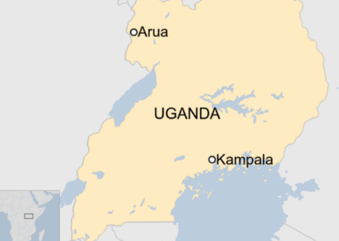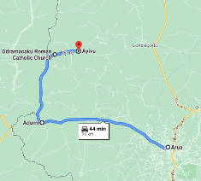

Fig. 1: Top - Map of Uganda showing Arua city and the capital city of Kampala. Bottom - Route from Arua city to the scene of lightning incident
Near the town of Odramacaku, in the remote countryside of Uganda is Abiria Primary School in a place called Ayivu (sub-county). All the children killed in the lightning incident of August 27th, 2020 went to school at Abiria Primary School. GPS coordinates of the scene of the lightning incident is 3.1151417, 30.8283933.
Driving from Kampala to Arua, the regional city, is ten hours on tarmac road and an additional two hours, on approximately 20km of murram road, to reach Ayivu.
- Setting of Ayivu and surrounding villages
Ayivu is a typical African village, covered with lush vegetation, grass thatched huts, and small iron roofed houses spread across meandering hills and valleys.

The murram road linking Arua to Ayivu is difficult to drive on because of potholes and gullies running through sections of the road. Driving becomes more difficult during rainy seasons.

- Lightning Strikes - first responders (witnesses) & survivors narrate
On the afternoon of Thursday, August 27th, 2020, children from two neighbouring villages, Gbuluku and Nyaute, were engaged in a competitive game of football. This was on a small open ground, something equivalent to a few tens of square meters, between a field of a few growing pine trees and a small hut that Mr. JN was building – like an upcoming compound of somebody’s homestead.

The children’s football team of Gbuluku village is called Anzu and that of Nyaute village is called Nyaute team. On the fateful evening, Anzu team was scoring ahead of Nyaute team by 3-0. It started drizzling but the game continued, the spectators and substitutes took shelter in the veranda of the nearby hut of Mr. JN.
The majority of children playing football that afternoon went to school at nearby Abiria primary school. AE, a 16-year-old, was supposed to be at school in form five had it not been the pandemic of covid-19. He now played for the Anzu football team of his village, Gbuluku.
About an hour into the game, AE was getting tired and he came to ask his young brother to substitute for him in the game. As he stood in front of his peers who were squatting on the veranda of Mr. JN’s hut, his hand reaching out for his brother, lightning struck, leaving him shocked and confused.
Four boys were thrown about four feet in front of the veranda and piled together. Six other bodies lay scattered nearby. Three surviving boys were either squatting or seated near their colleagues who lay on the ground. AE and others ran to alert nearby homesteads, about 100 feet away, about the incident.
Mr. RA, a local leader, was among the first witnesses (responders). He recalls that he found the bodies of the victims lying on the ground with their faces looking skywards. Their tongues were stuck at the back of their mouths (MA: obstructed airways). According to RA and other first responders, they administered first aid of moving the tongues of the victims out of their mouths to aid breathing. They called for nearby motorcycle riders who responded well and helped them move the very weak bodies of these children to nearby medical clinic in Odramacaku trading centre. They were encouraged by their observation that their hearts were still beating.
At the clinic in Odramacaku, one boy was declared dead and the body transferred back to the parents’ home for burial. A vehicle belonging to MS, an International Non-Governmental Organization (INGO), helped transport the nine others to Arua hospital. The road between Odramacaku and Arua is a stretch of about 20 km on a bad murram road. At Arua hospital these nine were declared dead on arrival.
- METHODOLOGY
Survivors who could still be traced from areas around or near Ayivu, near Odramacaku trading center, were gathered while working with UPF. Those who got in touch with the dead as first responders (witnesses) were sought for information that was helpful in understanding what actually happened. Translation was done by one of the local police officers.
Direct interviews were conducted for each survivor who was given chance to recall the incident. Interviewer guided discussion was used to reconstruct the incident.
- Institutional Review Board approval
The institutional review process was not possible because of covid-19 restrictions. The need to investigate this tragic incident came at a time when public offices were still closed to the public in Uganda because of the Covid-19 lockdown.

- Instrument and Consent
Mr. RE, a leader representing the local parish of Ayivu in the district council of Arua, was unanimously chosen to represent all parents in interactions with ACLENet team.

Subsequently, on behalf of all parents, RE signed the consent forms to authorize the interviews and photographing of the children survivors.
- Study Team and Training
The field study team was led by Richard Tushemereirwe and included George B. Bamu, Martin Omara, and Mary, a nurse from Kiryandongo hospital (herself a survivor of lightning in 2001).

The team was briefed by their leader before the onset of the journey from Arua. This was complemented by the regional UPF office in Arua city.

- Study Subjects
The ACLENet investigating team interviewed two categories of people. The first category comprised of the first responders (witnesses) who were the first people to come to the scene of lightning incident. Four witnesses were interviewed.

The second category was comprised of four survivors who were at the scene playing football or watching.
- Time period
The field visit to the lightning incident scene in October 2020 took three days – the first day was dedicated to orientation while the remaining two days were for direct interviews.

- RESULTS
A small, unfinished and uninhabited, grass thatched hut lies on the edge of the scene of the deadly lightning incident that claimed the lives of ten young children in Ayivu, near Odramacaku town (Fig. 2).

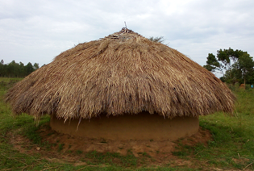

Figure 2: Most of the children who were injured were sitting on the typical raised earth foundation that extends as a small veranda around this unfinished hut, taking shelter from a drizzle. The top center point of the roof was not yet thatched so that rain and sunlight could penetrate to the inside.

- Reconstruction of the scene
On the raised soil surrounding the unfinished hut, what would be called a veranda, is where spectating children squatted as they took shelter from the drizzle which the football players ignored and continued playing (Fig. 3)

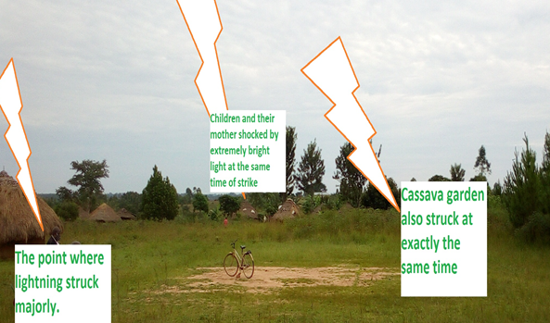

Figure 3: A bicycle stands in the center of the field which was being used for the football game during which lightning struck.

- Feedback from first witnesses from the neighborhood
1. MM, 42 years.
MM is the parent of two sons, AE, 16 years - grade 5, one of the survivors, and AS, 14 years – grade 4, one of those who died.

AE told her mother that his younger brother, AS, had been struck by lightning. She immediately ran to the scene. She found four of the victims were piled near a hut besides the football playground, three facing in one direction, and another lying across their feet, with six more scattered a few meters away with their bodies facing upwards.
AE sustained burns on his back, sides of his trunk, chest and abdomen. When MM, the mother, reached the scene, she became overwhelmed, collapsed but managed to make an alarm. She then, immediately, started to remove the tongues (clear the airways) of the five she thought were still alive. She believed the others to be already dead.
As four other responders joined her in the rescue and after executing the `first aid’ on the five, she decided to run and inform her relatives of the disaster. She did not learn how the victims were taken to the nearest clinic until much later from those who took them there.
2. BM, 44 years.
BM is the mother of one of the dead boys, GB, 16 years, who was in grade 5 at Abiria primary school.

It was at around 5 pm, in the evening, when she learnt of the disaster through the alarm that was made by the first arrivals at the scene where lightning struck. She was bare-chested at the time she arrived. The place of the scene appeared to be dark, with a drizzle so it was not easy to identify her son among the victims.
BM saw the boys lying down and facing upwards. It was at that time when she was able to identify her son. She realized that his body temperature was very high, the tongue was white and as she touched the eyes, they would not close. She, in addition, saw burns at the back, forehead, chin, face, sides, feet, and private parts.
3. AL, 31 years
AL is the mother of, AY, 14 years in grade 3 at Abiria primary school – one of the survivors.

AL was the third arrival at the scene. She heard an alarm, came out of the house and saw boys running haphazardly from the scene and became suspicious so she proceeded there to find out what had happened.
AL found the victims lying on the ground and tried to remove their withdrawn tongues from their mouths to facilitate breathing. She was informed by one of the boys that her son could still be alive, so she concentrated on him, trying to do first aid, and immediately they carried him, together with his brothers to their home. She removed his damaged clothes, and immediately, a Good Samaritan took him on a motorcycle to a nearby medical clinic in Odramacaku town.
AY, one of the three survivors, was a spectator. He also sustained burns on the back, chest, elbow and buttocks.
4. OC, 16 years, in grade 5 at Abiria primary school
OC is also a student at Abiria primary school, just like the rest of the boys. She was at home cooking and suddenly heard an alarm and to her surprise saw the NYAUTE team running away from the field where football was being played. She was immediately told that some of the boys had been struck by lightning.

She was immediately told that some of the boys had been struck by lightning.
Her brother, AF, told her that his leg had been hurt but he would be alright by God’s Grace. She took him to a medical
clinic for treatment of a superficial burn on his foot which took a week for the leg to heal.
The brother also had wounds on the buttocks and the back. She was told that some boys were squatting, while others were seated on the verandah, leaning against the wall of the small hut adjacent to the playground.
- Injuries Sustained by Survivors
Four survivors were interviewed to ascertain any injury, physical or psychological, that might have been sustained after the reported lightning incident.

Immediately after the lightning incident, each of these four were admitted in a nearby medical clinic at Odramacaku

Table 1: Summary of injuries and ailments to the four survivors of lightning incident near Odramacaku
OBSERVATIONS | From Nyaute village.  MB, 14 | 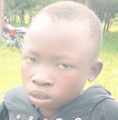  From Gbuluku village.  AY, 14 | 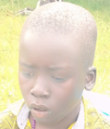  From Gbuluku village.  AF, 11 | 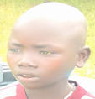  From Nyaute village.  AM, 11
- What do you remember? | He only realized his surroundings when he was already down, he can’t remember what exactly happened. | He only remembers when he was already lying down on the ground. | He only remembers that he was lying on the ground. | He remembers seeing something like fire and very bright light.
- How have you been feeling ever since the incident happened? | He has been feeling pain on the shoulders. | Ok.  He is feeling better now | He has not been feeling well, he feels scared most times. | Still scared of lightning, fearing that it might come back anytime.
- How have you been sleeping? | Has been feeling pain at night when in bed. | He is sleeping well. | He has been restless while sleeping at night (scared most times). | He is sleeping well.
- Where were you when the incident happened? | Was sitting on the veranda when lightning struck. | He was sitting under the veranda. | He was squatting on the veranda. | He was sitting on the veranda.
- Other physical observations. | 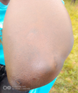 | Round skin scar on buttocks. | 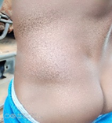  Scarred skin on the back.
 | Sustained injuries with scarred skin on the left elbow and right leg as shown in the photos. | He has visible burns (scarred skin) on the right elbow, back, waist, and the buttocks as seen in the photos. | Visibly scarred skin on the waist, buttocks, right knee and on the left side of the back as seen on photo above. | Scarred skin can be seen on the left side of the back as shown in the photos.
 | His cloth was visibly burnt on the left elbow as seen in the photo. | He has lost appetite of eating. |  | He has no appetite for eating food.
 | 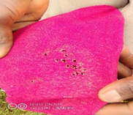 | 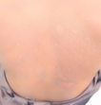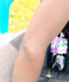 | 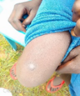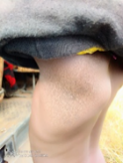
 | He has lost appetite of eating

Trading Centre and were discharged after three days. The observed injuries and ailments are summarized in Table 1.
- Further observations and Global Lightning Data
The witnesses in Gbuluku village volunteered information that, simultaneous to death of children, the following happened:

- About 40 meters from the lightning incident field, shrubs, cassava, and potatoes leaves were burnt in a neighboring field. This was later cleared by the owners of the garden because it was associated with bad omen.
- Deafening noise and extra bright flash, were observed in the homesteads neighboring the field of main incident.
- About 5 children in the neighborhood, about 80m away, were shocked and jumped in fear into their mothers’ laps.
Inside the hut shown in Figure 1, it was observed that the inside part of the grass thatching was scorched. It looked like a flame of fire started on the grass inside and later stopped without causing much destruction. The witnesses remember seeing smoke coming from inside the grass thatching.
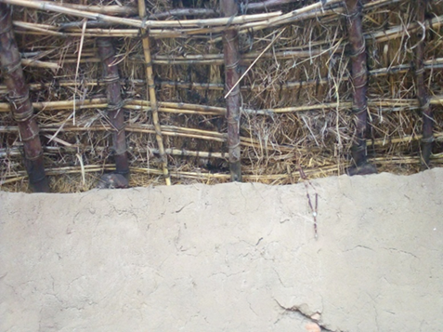
Rosary
Figure 4: Photo of the wall where thatch roof meets the mud wall. The inside was scorched by fire apparently started by lightning. A rosary was hanged to chase away evil spirits

Mr. JN has abandoned plans to finish and settle in it. The land around the hut is owned communally by the extended family headed by his father. Attempts by the family to sell the field consisting the hut have also failed because no one in the neighborhood is prepared to buy a cursed/demon possessed piece of land.

A rosary had been hung on the scorched grass thatching and some witnesses claimed this had the ability to chase away evil spirits that were thought to have caused this incident (Fig. 4).

The investigating team consulted with Vaisala Inc., the operators of Global Lightning Data (GLD-36O) to ascertain the occurrence of lightning in and around the scene in the evening of Thursday August 27th, 2020 (Fig 5).

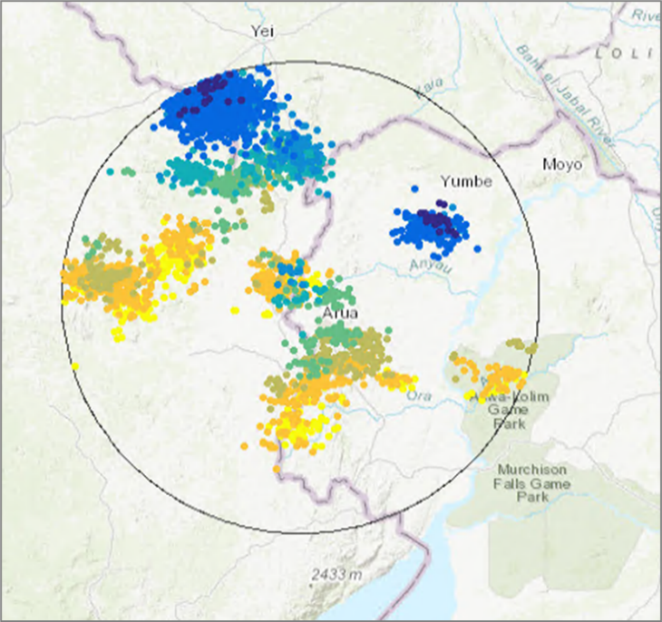
Figure 5: GLD-360 data in a 25km radius around the lightning incident scene, between 3 – 8 pm on August 27th, 2020. It can be seen that the place was cloudy with many lightning flashes.

The GPS coordinates were submitted for use in the search and the time period was specified as between 3 – 8 pm in the evening.

The GLD-360 data indicated that there were many lightning flashes in the specified period in a 25 km radius around the scene of incident (figure 4). This corroborated the time given by witnesses as ‘approximately 5 pm in the evening.’

- Comments from general public
Members of the public, after learning of the ACLENet’s team presence in the village on the first day, came forward to volunteer information. They were eager to narrate how the lightning incident happened and the unfolding of subsequent events. Much of what they had to offer was hearsay and was disregarded by the investigating team.

However, these members of this general public expressed views which were important in the overall picture of Disaster Risk Reduction (DRR) plus Disaster Response and Management (DRM).

They expressed their dissatisfaction towards government response to this lightning disaster. After the incident, no member of the district disaster committee or ministry responsible for disaster response had ever visited the scene or interacted with affected families. This left them wondering if there is any program responsible for disasters from the government.

They further asked whether they should expect any relief item(s) or compensation, especially the families who lost children in this lightning incident. The investigating team referred these people to their local district authorities.

Also, members of the public explained that the rosary hung in the hut was to help in repulsing evil spirits which are thought to be responsible for the deadly lightning incident.

- DISCUSSION
Results obtained from this investigation were reviewed against the objectives set out at the start of this exercise.
The scene and the emerging of events, as obtained from interviews, remain intriguing because of language barrier between interviewers and respondents. Dramatic expressions filled with emotions gets lost in the process of translation.
Additionally, the presence of a police officer, despite aiding in the translation for this investigation, is always a source of anxiety for both adults and children so some responses may have been hampered. Expectations, like some respondents had for relief material compensation, sometimes bring out a narrative different from the actual ones.
However, most pieces of information were corroborated from different witnesses and survivors to produce a coherent picture of events as they emerged that fateful Thursday at the end of August 2020.
- Reconstructing the lightning incident
The surviving children who suffered injuries like skin burns and other forms of trauma lacked the capacity for a vivid narration. This was mainly due to their young age with lack of confidence to express themselves or just not being able to remember events or confusion generated by the tragic events.

Nonetheless, their testimonies are filled with critical pieces of information. Pieced together, the turn of events was most tragic immediately after the lightning bolt and more dramatic afterwards. The adults who responded to the first alarm simply did not know what to do in medical terms. Therefore, there was no first aid given that can be talked about.
From testimonies, the children were seated on the raised soil surrounding the hut or squatting with their buttocks touching the ground. This can also explain the burns which were consistently located on the buttocks and backs. This also suggests that the mechanism of injury was through a ground current.
Respondents also corroborated the smoke seen emerging from the hut which agrees with the signs of a fire which scorched the inside surface of the grass thatching.
Why did the fire not burn the whole grass thatching? Most probably, because it continued drizzling, the rainfall extinguished the fire.
- Spiritual causation
Members of the public, especially those who talked to investigators, believed that there was a spiritual cause to this lightning incident. It is not something solid that they could point a finger at but they all believed there must have been demons responsible for this tragic incident.

A rosary was hung inside the hut to chase away the demons. For lack of a solution, this is what has come in place of a Lightning Protection System (LPS).

Cassava and potato plants scorched by lightning were immediately uprooted as another way to disassociate the garden owners from the evil spirits or bad omen.
The lack of solution to lightning hazard seems to create hopelessness especially when it results in death in the local population. This hopelessness, in turn, creates a void which can only be filled by conspiracy theories involving a spiritual causation. It is a process of myth creation that led in the opposite direction of lightning safety.
- Ailments and Long-term medical conditions.
Most of the skin burns sustained by survivors were superficial and located either on the back or buttocks. This suggests that it was from contact with a hot surface. It further suggests that the mechanism of action for this lightning incident was through ground current, through the wall and soil of the veranda.

Corroborating information came from the testimonies of the survivors who recall that they were seated on the ground that is the veranda (or raised soil) around the hut. They further stated that some had their backs leaning against the wall of the hut.

MB, 14, the first respondent among the group of survivors interviewed, expressed persistent pain in the shoulders. This pain increases when he gets into bed trying to sleep.

Children related a chronic sense of fear raising concerns about survivors, families, and other villagers suffering Post-Traumatic Stress Disorder (PTSD). Other common sequelae of lightning injury include brain injury often manifested as learning disorders in children. These could not be assessed due to school closures during Covid-19.
- Disconnect between government disaster response
Uganda is a participant in international efforts to reduce and manage disasters and is a signatory to the Sendai Framework (need REF or link).

As a result of recommendations from the United Nations International Strategy on Disaster Reduction (UN/ISDR), the Uganda government established a ministry (department) responsible for disaster risk reduction. The Ministry of Disaster Preparedness and Refugees was to include Disaster Risk Reduction (DRR) in the Sustainable Development agenda - https://www.undrr.org/about-undrr/history . Consequently, in planning for and mainstreaming of DRR, the ministry has established disaster reduction/response committees at local government (district) level.

However, the discontent expressed by the populace of Ayivu suggests a disconnect between the district DRR committees and the people they are constituted to serve. It might be a matter of resources. If the local district committee is not provided with enough resources and appropriate infrastructure to support the communities, then they might remain just on paper.
Alternatively, it might be a problem of strategy and work-plans. If the committee or the central government department does not come up with appropriate work plans, the district committees might remain useless.
It might be a problem of both lack of resources and lack of work-plans. For an example, in the case of this lightning incident in Ayivu, if a properly stocked ambulance were available to respond in time, loss of life could have been prevented or reduced. Also, if the district committee were educated in lightning safety, they would take appropriate messages to the affected communities.
In the current situation pertaining in Ayivu, there is no ambulance to save lives and no message to promote lightning safety.
So, it can be stated that, the district committee has not responded to the incident at all because they have no resources and/or message to take to the affected community.

- CONCLUSIONS

Some of the findings from a prior mass casualty lightning investigation in Uganda (Mongoyo REF) can be called forward to this study:
- This was a mass casualty incident that overwhelmed the village’s capacity and medical resources to care for the victims.
- Fear, superstitions, and blaming of curses was common in the community after the incident.
- There were no safe places to go and no warning of bad weather or lightning danger.
Another finding is based on reports from the villagers that they had not been well served by the new decentralized local response team for disaster management since no one from the team had contacted them, offered aid, nor sought their accounts by the time our team visited three months after the incident occurred.

- ACKNOWLEDGMENT

The ACLENet team appreciates the support given by the Uganda Police Force (UPF) in the work of scene investigation where this incident happened. We are also thankful to our generous donors who contributed money that funded this investigation.

- REFERENCES
Cooper, M.A., R.L. Holle, R. Tushemereirwe, and C.J. Andrews, 2018: African Centres for Lightning and Electromagnetics Network (ACLENet): Progress report. Preprints, 34th International Conference on Lightning Protection, September 2-7, Rzeszow, Poland, 7 pp.
Cooper, M.A., R. Tushemereirwe, M. Guthrie, and R.L. Holle, 2021: Lightning protection challenges in the developing world. Online presentation to 10th Conference on the Meteorological Application of Lightning Data, American Meteorological Society, January 10-15.
Holle, R.L., M.A. Cooper, R. Tushemereirwe, and R. Said, 2021: Lightning occurrence and casualties in Uganda. Online presentation to 10th Conference on the Meteorological Application of Lightning Data, American Meteorological Society, January 10-15.
Holle, R.L., 2013: Lightning-caused deaths and injuries in the vicinity of trees. Preprints, 6th Conference on the Meteorological Application of Lightning Data, January 7-10, Austin, Texas, American Meteorological Society, 8 pp. Available at https://ams.confex.com/ams/93Annual/webprogram/Paper215238.html.
Holle, R.L., 2016: Lightning-caused deaths and injuries related to agriculture. Preprints, 6th International Lightning Meteorology Conference, April 18-21, San Diego, California, 5 pp. Available at www.vaisala.com/sites/default/files/documents/Ron%20Holle.%20Lightning-caused%20Deaths%20and%20Injuries.pdf.
Holle, R.L., and M.A. Cooper, 2016: Lightning-caused deaths and injuries at schools. Preprints, Preprints, 33rd International Conference on Lightning Protection, September 25-30, Estoril, Portugal, 5 pp.
Holle, R.L., and D. Zhang, 2017: So you think you know lightning: A collection of electrifying fast facts. Booklet, Vaisala, Inc., 64 pp. Available at www.vaisala.com/sites/default/files/documents/Lightning-Booklet.pdf.
Tushemereirwe, R. and M.A. Cooper, 2021: Investigation of lightning mass casualty incident at Mongoyo School, Uganda. Online presentation to 10th Conference on the Meteorological Application of Lightning Data, American Meteorological Society, January 10-15.

