Kakamega: Lighting Strikes, Kills Man Standing Outside His Kitchen - Kenya
https://www.tuko.co.ke/kenya/counties/552490-kakamega-lighting-strikes-kills-man-standing-kitchen/
19 June, 2024
Faith Chandianya
A family in Kakamega County is grieving after their relative Rashid Ondewa passed away after being struck by lightning.
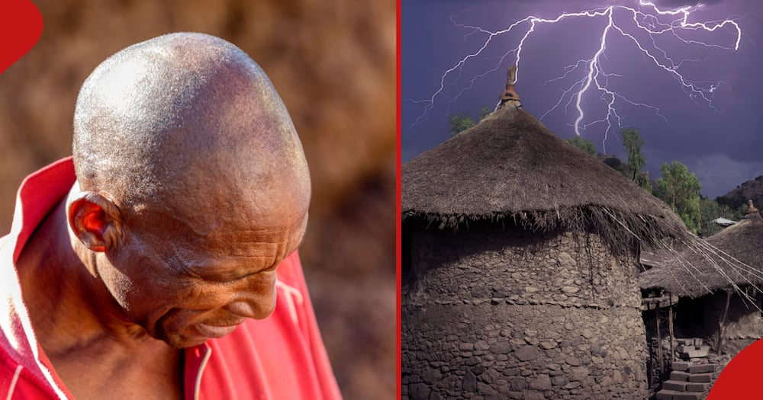
Figure 1 Efforts by Rashid Ondewo's family to rush him to the hospital were futile , as he did not survive.

When did lightning strike Rashid Ondewa?
The middle-aged man was said to be at his residence when the tragedy occurred.
According to a Citizen Digital report, the incident occurred around 7.30pm while the man was standing beside his kitchen at his home in the Eshilarumwa area of Kakamega county.
Ondewa's family discovered him lying outside his kitchen and promptly took him to the hospital, where he was pronounced deceased.
The deceased's family described Ondewa as a significant figure within their household, leaving a substantial void in their lives.
"He has left a huge gap in our family. Rashid was an instrumental person in the family,” one relative said.
Lightning strikes 5 family members in Nakuru
Earlier TUKO.co.ke reported that a wave of shock swept through the residents of Karandit village, Kuresoi South, as lightning struck five family members inside their home amidst heavy rainfall.
Emily Cheruiyot, the mother of the affected teenagers, revealed that one of the children was engrossed in using their phone, oblivious to the looming danger of lightning.
Cheruiyot recounted that following the strike, the children were left crawling on their bellies, prompting a neighbour to transport them to the hospital for urgent medical attention swiftly.
Doctors at the Keringet Nursing Home and Olenguruone sub-county hospitals where the teenagers were rushed confirmed their stable condition.
Lightning kills 2 brothers in Kakamega
In a separate incident, grief engulfed Mayuke village, Malava Constituency, after two brothers who were students at a local secondary school were killed after they were struck by lightning while studying.
The bodies of the Form Three and Form Two students at Bukakhunga Secondary were burnt beyond recognition by the lightning inside their house during a heavy downpour.
David Wanjala, the father of the boys, said he saw off his two children, aged 16 and 18, at their house to conduct studies before the unfortunate incident happened.

