**[Lightning Safety Concerns in Zimbabwe](http://globalsevereweather.earthnetworks.com/2016/02/lightning-safety-concerns-in-zimbabwe/)**

Posted by [Earth Networks](http://globalsevereweather.earthnetworks.com/author/earthnetworks/)[Africa](http://globalsevereweather.earthnetworks.com/category/africa/), [Zimbabwe](http://globalsevereweather.earthnetworks.com/category/africa/zimbabwe/)[No Comments](http://globalsevereweather.earthnetworks.com/2016/02/lightning-safety-concerns-in-zimbabwe/#comments)

17 Feb 2016

<http://globalsevereweather.earthnetworks.com/2016/02/lightning-safety-concerns-in-zimbabwe/>

**Life-threatening lightning strikes in Zimbabwe are, unfortunately, common occurrences. We took a look at two of the many lightning incidents that compromised civilian safety in the country during the month of December 2015 in Hwange District and Rusape.**

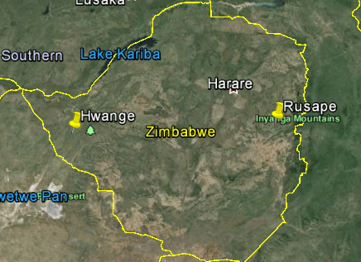

A family was chased out of their home during a storm by multiple strikes of lightning on 2 December 2015. Three separate strikes of lightning struck the family’s home in quick succession, reducing it to rubble and destroying property. The bizarre event took place in Lusaba Village in Hwange District, Zimbabwe.

Video Player

00:00

00:27

The above video shows the lightning flashes over the northwestern region of Hwange on 2 December. Over a 12 hour period, Earth Networks Total Lightning Network detected over 4,000 strikes of lightning over the area. We detected both cloud-to-ground (yellow) and in-cloud (purple) lightning strikes during the storm.

The three members of the family, including a baby, were able to escape the hut with their lives but unfortunately lost everything else. While the baby and its mother escaped unharmed, the grandmother was rushed to the hospital and treated for shock. A State Media news crew visited the rubble and asked “Whoever heard of lightning striking the same place twice, let alone thrice within minutes?”

The widely accepted statement that lightning cannot strike the same place twice is, in fact, a myth. It is actually a proven fact that lightning can and is likely to strike the same place more than once. What makes this story incredibly strange, however, is that this same family was affected by another lightning strike in 2011. People don’t realize just how common and deadly of a force lightning is. Dispelling lightning myths is critical to promoting lightning safety worldwide. The below video shows visual proof as lightning strikes an area of water 7 times in a row in Texas, U.S.

**17 December 2015:** On the opposite side of Zimbabwe in Rusape, a lightning strike killed a young man while he was listening to music with headphones on. When it looked like it was going to rain, 20 year-old Editor Mamvura of Nyavanhu Village went to seek shelter in the kitchen hut with his mother. When he was 15 metres from the hut he was struck by the lightning and died on the spot.

Video Player

The above video shows the large amount of lightning present near the eastern border of Zimbabwe. A highly concentrated area of total lightning from 2-3pm UTC over Rusape are believed to contain the strike that ended the life of Mamvura. Basic lightning precautions could have aided in stopping this event. Most time when it appears that it is going to rain it is often too late for individuals to seek shelter. The best time to seek shelter from lightning is when the nearest strike is about 10 miles away. Lightning sensors and forecasting tools from Earth Networks can aid in this life saving effort. [ENcast](https://www.earthnetworks.com/Products/ENcast/), a leading cloud-based forecasting tool, leverages hyper-local weather data and ingested data from the top performing models to reduce forecast error and track total lightning throughout the world.