**Lightning Strike Kills Eight Cows in Ntungamo-Uganda**<https://thesource.co.ug/current-affairs/lightning-strike-kills-eight-cows-in-ntungamo/>  
  
18th July, 2024

Barham Akatukunda

[[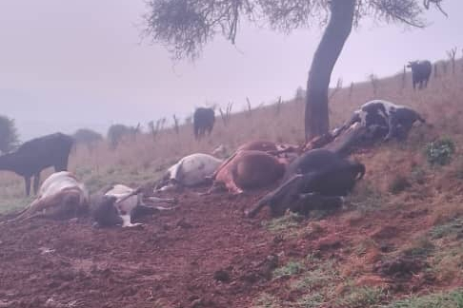](https://thesource.co.ug/current-affairs/lightning-strike-kills-eight-cows-in-ntungamo/%3C%20%20%20%20%3Cspan%20class=)](https://thesource.co.ug/current-affairs/lightning-strike-kills-eight-cows-in-ntungamo/%3C%20%20%20%20%3Cspan%20class=)

Eight cows were struck by lightning in Rugarama North Sub County, Ntungamo District.The incident occurred on Tuesday night during a heavy downpour in Mukyondo Cell, Kyafora, Rugarama North Sub County.

According to Wilson Kabegambire, a local resident, four of the cows belonged to Kenneth, who had rented the farm of Kagumire Tumushabe. Tumushabe, also a resident of the area, lost four of his own cows in the incident.

The owners discovered the dead cows on Wednesday morning when they went to milk them.