4 Rwandan gorillas killed by lightning in Uganda
February 8, 2020
Written by OUR REPORTER
https://observer.ug/news/headlines/63459-4-rwandan-gorillas-killed-by-lightning-in-uganda
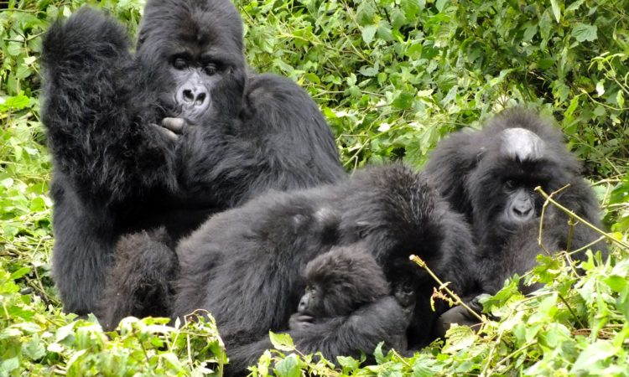
Four mountain gorillas from Volcanoes national park in Rwanda have been found dead inside Uganda's Mgahinga national park in southwestern Uganda.
The gorillas are suspected to have been killed by a lightning strike on February 3. The deceased gorillas include three adult females and a male infant.
The Hirwa family of 17 members crossed to Uganda’s Mgahinga national park on August 28, 2019 from Volcanoes national park in Rwanda.
According to a statement from the Greater Virunga Transboundary Collaboration (GVTC), a transboundary organisation coordinating the management of natural resources in the Virunga massif, the four mountain gorillas were all from the Hirwa family in Rwanda.
Following the discovery of the dead gorillas, GVTC says in the statement that it led a team accompanied by the Uganda Wildlife Authority (UWA), Rwanda Development Board (RDB) and Gorilla Doctors to assess the cause of death and identify the state and health of the other family members.
A post-mortem was performed and samples collected for detailed laboratory analysis. Based on the gross lesions from the post-mortem, field assessment observation and history, the tentative cause of death for all four individuals is likely to be electrocution by lightning.
"Confirmation of the cause of death will be issued after a histopathology laboratory exam of the collected samples, which is expected to take 2-3 weeks.
The group is among many other mountain gorilla families that range within the Virunga massif ecosystem, which is comprised of three regional parks: Volcanoes national park in Rwanda, Virunga national park in the Democratic Republic of Congo and Mgahinga Gorilla national park in Uganda.

