**Natural disasters kill 23, lightning claims 20 [Malawi]**

December 21, 2020

[Natural disasters kill 23, lightning claims 20 | Malawi Nyasa Times - News from Malawi about Malawi](https://www.nyasatimes.com/natural-disasters-kill-23-lightning-claims-20/)

https://www.nyasatimes.com/natural-disasters-kill-23-lightning-claims-20/

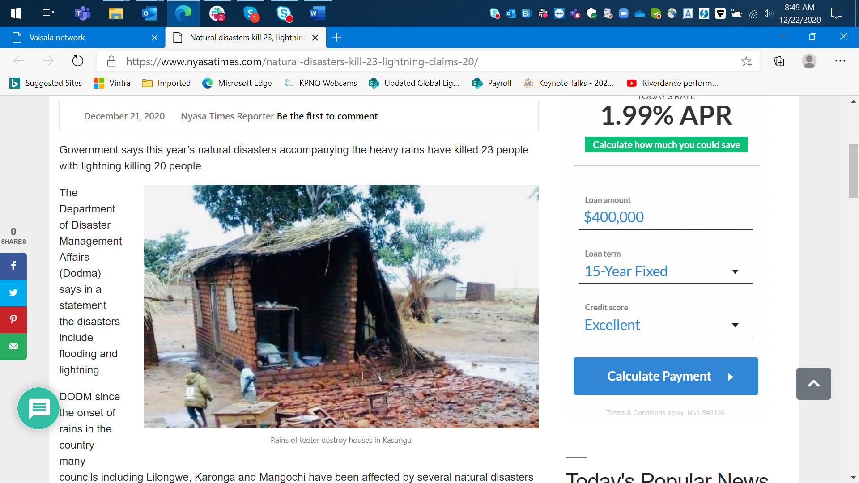

According to Mwafongo, so far, the country has recorded a total of 12,031 houses affected and 166 injuries.