60 students hurt as lightning strikes St Brigid’s Nangwe Secondary School - Kenya
Raphael Wanjala And Jackline Inyanji 05th Mar 2019 00:00:00 GMT +0300
https://www.standardmedia.co.ke/article/2001315258/60-students-hurt-as-lightning-strikes-school
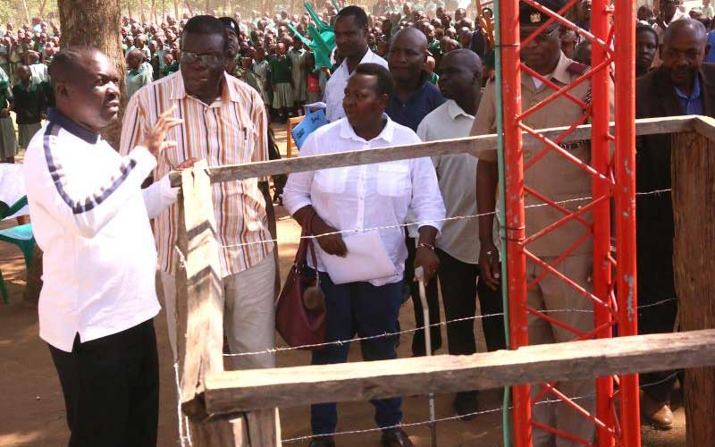Navakholo MP Emmanuel Wangwe (Left) shows one lightening arrester he has helped install at Shilakwe Primary School on Sunday. [Benjamin Sakwa, Standard]At least 60 students of St Brigid’s Nangwe Secondary School in Kabuchai Constituency were struck by lightning on Sunday night.
School Principal Fransiscah Munyasia said the students were taken to Khalaba Medical Centre, where 50 of them were treated and later discharged.
The remaining 10 were admitted to the same facility. Hospital attendants yesterday said the 10 were in stable condition.
“The unfortunate incident happened when the girls were conducting their evening preps. The lightning struck and the frightened girls started calling for help. We rushed those injured to hospital,” said Ms Munyasia.
SEE ALSO :60 students injured in lightning strike
Michael Milimo, a medical officer at the facility, said those admitted had suffered burns but were responding well to treatment.
Lightening arresters
“They suffered burns as a result of the lightning but they are responding to treatment and we are hoping that they will be discharged soon,” Mr Milimo said.
Meanwhile, the national and county governments have been urged to install more lightning arresters in schools and market centres to reduce cases of people being struck.
Navakholo MP Emmanuel Wangwe, who noted that the county was prone to heavy rains, said schools had been affected the most by lightning incidents.
Deaths have also been recorded.
“Cases of lightning strikes are on the increase and schools have fallen victim of such disasters. We need efforts from both the national and county governments to safeguard our students,” Mr Wangwe said.
Last year, two pupils died and 22 others were injured during ball games held at Esumeiya Primary School.
A 48-year-old man was also struck by lightning while in his house in Mwambuli village, Lugari sub-county.
His three children were left with burns and their house destroyed.
Five dead
Following the incidents, Wangwe has installed eight lightning arresters in the constituency and pledged more.
Buying and installing one arrester, he said, cost Sh2.5 million.
“There is need for construction of a disaster centre to help train locals and institutions on how to respond during lightning incidents in schools and homes. Many people do not know the dangers,” Wangwe said.
In August 2015, seven pupils were struck by lightning while playing football at St Luke Lumakanda Secondary School. Five of them died on the spot.
In 2010, 12 people died on the spot after lightning struck them in Navakholo, where they were attending a church service.

