School classrooms burnt after lightning strike at KZN school [South Africa]
7 March 2018 Thami Magubane
https://www.iol.co.za/mercury/news/school-classrooms-burnt-after-lightning-strike-at-kzn-school-13640678

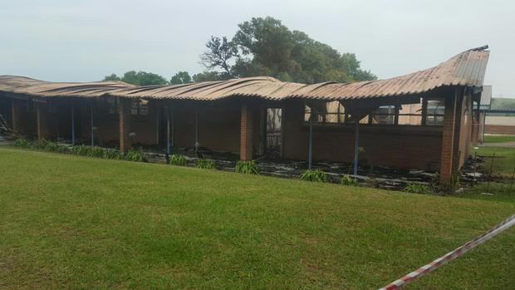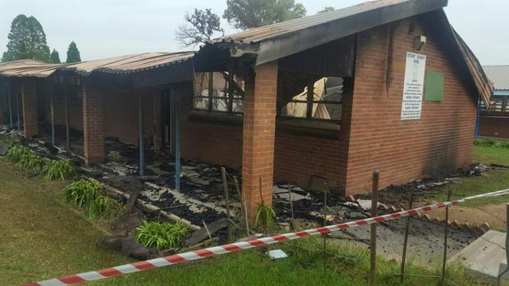
Four Grade 12 classrooms at Estcourt Secondary School were badly damaged when lightning struck the building.
The lightning strike, during a storm on Tuesday night, led to a fire that burnt chairs, tables, books and test scripts of about 180 grade 12 pupils in the clasrooms.
The school's principal Marilyn Jordan said although authorities were still investigating the cause of the fire, a preliminary investigation suggested that the fire had started due to a lightning strike at about 11 pm.
“It took a long time for the fire to be put out,” said Jordan.
Jordan said scripts, for tests that had already been conducted had been lost in the fire and those tests would have to be done again.
“We lost all the matric scripts that were in the classroom, one teacher had about 500 scripts that he had locked in the cupboard in one of the classrooms. We will now have to redo those, we cannot rush the students or the teachers because what happened there is not their fault,” she said.
She said in the interim they had managed to place one classroom in a former hostel at the school.
Jordan said the school catered to students who are not financially well off and they would welcome any assistance to help them renovate the classrooms.

