Lightning strike kills three year old girl in Pader [Uganda]
The Independent March 10, 2024
https://www.independent.co.ug/lightning-strike-kills-three-year-old-girl-in-pader/

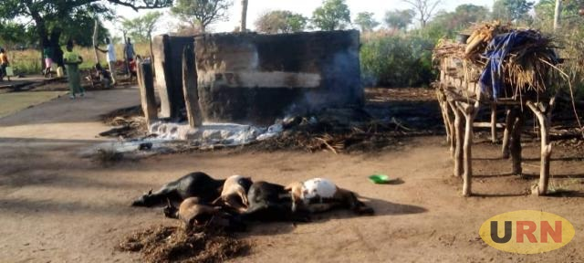
The hut struck by ligthning at around 8pm leaving a baby of 3 years dead. PHOTO URN
Pader, Uganda | THE INDEPENDENT | A 3-year-old girl dead from Lapunu-makwar village, Lalogi parish, Lapul Sub- County has been confirmed dead after being struck by lightning.
The incident happened at around 8pm on Friday during a downpour that took almost three hours.
The deceased had been identified as Lakot Oliver. According to the father of the deceased Cosmas Obur, the lightning burnt all the items inside the house killing his daughter instantly. He adds that five goats taking shelter were struck dead.
The LC 3 Lapul sub-county Mr Ali Peter Bosco confirmed the report saying the incident happened when the mother of the deceased went out to remove grains from the rain before lightning struck and burnt the house completely. He condoled with the family and urged well-wishers and district interventions to help the affected family.
Justine Ocen, the Pader district vice chairperson LC V also condoled with the affected families saying that they should document the incident and hand it to the office of the sub-county chief. However, he says the district will help source for support from willing partners.
Meanwhile, the Pader district chairperson for disaster, preparedness and management who doubles as the district chief administrative officer, Michael Wangi says he is yet to receive formal reports from the sub-county in order to handle such incidences.

