Project | Zimbabwe Lightning Occurrences
February 8, 2013
LOCATION: Zimbabwe | PROJECT LAUNCHED: 2012
http://epics.ieee.org/projects/project-zimbabwe-lightning-occurrences/
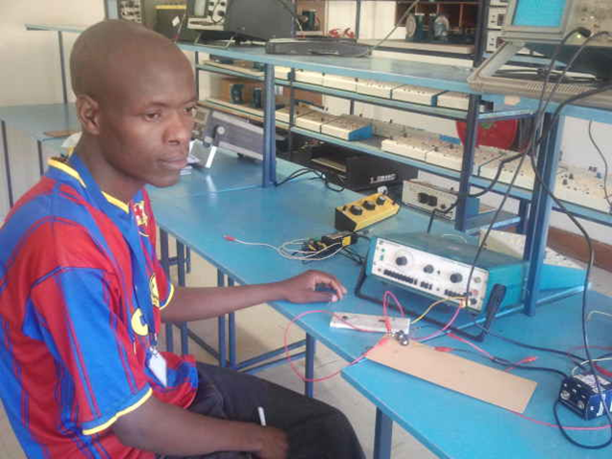
PROJECT LEADS:
Department of Electrical Engineering, University of Zimbabwe

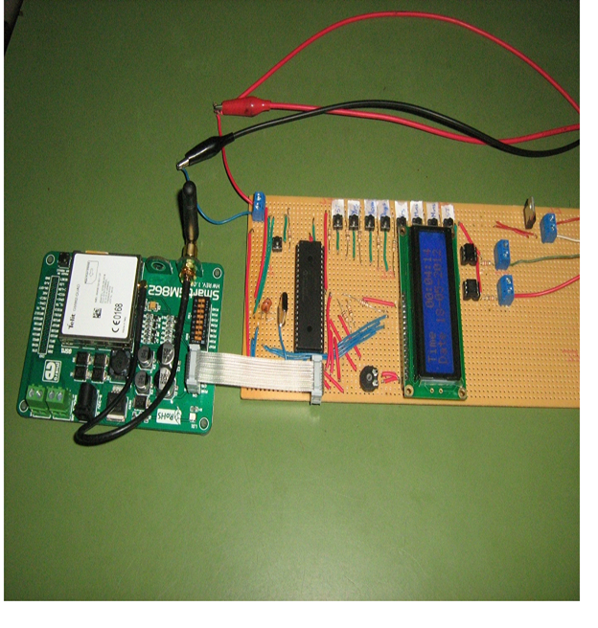
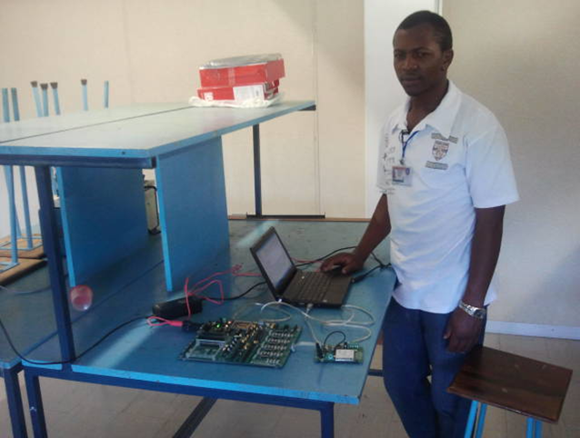
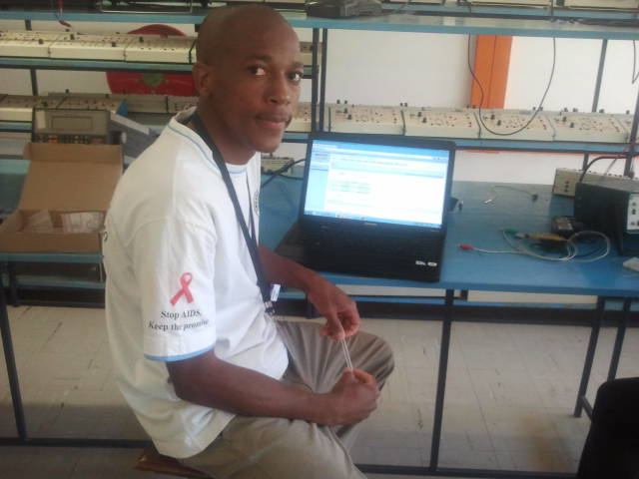
PROJECT OVERVIEW
In Zimbabwe, lightning is cause to a large number of deaths annually. Due to underfunding, lightning research has come to a standstill. At one point, the Zimbabwe Electricity Supply Authority (ZESA) sponsored a program to install lightning counters in strategic locations, but they themselves failed due to logistical problems and the counters themselves had been damaged by lightning.
In order to revitalize this research, fourth-year students from the University of Zimbabwe, in the Department of Electrical Engineering, will design and build an intelligent electronic device (IED) which will detect lightning incidence and activity in select locations throughout the country. The device will aim to detect lightning occurrences, the location and the time of the event, and serve as an early warning sign to lightning occurrences and their severity.
The IED will also have an embedded SIM card and mobile radio technology so that it can convey detected information to a central location via GSM network. Overall, students will gain experience in design, high-voltage engineering and communications engineering.
The university students will work closely with the Zimbabwe Institution of Engineers, Meteorology Department and a local high school. The high school students will assist in surveying the work and information collected through the project, getting valuable exposure to engineering skills. ZESA will provide technical and logistical support.
PROJECT PARTNERS
Department of Electrical Engineering, University of Zimbabwe | Zimbabwe Institution of Engineers, Meteorology Department

Get involved with EPICS in IEEE and help support and motivate tomorrow's engineering leaders to "keep the planet driving forward."
DONATE TODAY!
EPICS in IEEE empowers students to work with local service organizations to apply technical knowledge to implement solutions for a community’s unique challenges.

