Africa, a thunder and lightning hot spot, may see even more storms

By SHOLA LAWAL

THE NEW YORK TIMES | FEB 11, 2020 | 11:15 AM

<https://www.baltimoresun.com/travel/travel-news/sns-nyt-africa-experiencing-more-lightning-thunder-20200211-aj7g25reonb63o7dezamqbgccq-story.html>

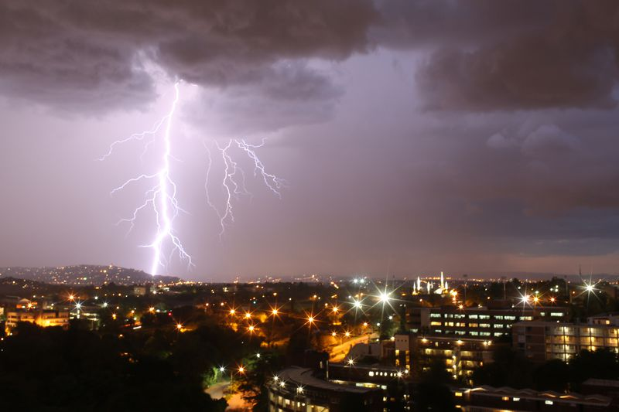

Lightning strikes over Johannesburg during a storm on December 14, 2013. (Alexander Joe/AFP via Getty Images)

Africa is experiencing bigger and more frequent thunderstorms as global temperatures rise, according to researchers at Tel Aviv University.

The continent already has many of the world’s lightning hot spots, with storms that can be extremely destructive and, sometimes, deadly. This month, for example, a conservation group reported that four rare mountain gorillas had been electrocuted by lightning in Mgahinga National Park, Uganda. In a calamitous episode in 2011, a lightning strike on an elementary school in the same country killed 20 children and injured nearly 100.

Mass casualties like that are rare. But meteorologists wondered at the time whether thunderstorms were becoming more common in Africa in the era of climate change.

The answer, according to the new research, published in January in the American Meteorological Society’s Journal of Climate, is yes. An increase in temperatures in Africa over the past seven decades correlates with bigger and more frequent thunderstorms, researchers found.

If the finding holds up, that could mean more fatalities and more economic damage. “Lightning is the No. 1 killer when we talk about weather in tropical countries,” said Colin Price, professor of Atmospheric Sciences at Tel Aviv University and the study’s lead author.

There is no organized data for lightning casualties that covers all of Africa, but a 2018 study of eight countries put the number of deaths at about 500 per year. Globally, estimates range from 6,000 to 24,000 deaths per year.

Africa faces elevated risk for reasons for that go beyond the relatively high frequency of storms on the continent.

Poor urban design and infrastructure, for example, can worsen flooding during heavy storms, according to Alistair Clulow, a professor of agrometeorology at the University of KwaZulu-Natal in Durban, South Africa. That, in turn, can make lightning strikes more deadly because water conducts electricity.

Rural communities also face risks. Farmers and herders work in the open, which makes them more vulnerable during storms. Houses in rural areas often lack plumbing or wiring that can act as grounding against lightning strikes.

Global data on the economic impact of thunderstorms is patchy, but a 2008 assessment by the National Lightning Safety Institute in Louisville, Colorado, placed the annual costs in the United States at $5 billion to $6 billion. That includes forest fires and damage to structures from lightning strikes, and flooding from heavy rains.

Price and his co-author, Maayan Harel, looked at 2013 thunderstorm data from the World Wide Lightning Location Network, determined which climate-related variables had the most influence on storms and then used those variables to build a model that created a simulated history of thunderstorm activity over Africa from 1948 to 2016.

The project took seven years. Their next study will look at thunderstorms in Southeast Asia, another tropical hot spot.

Because of data limitations and differing methodologies, there is no consensus, for now at least, on how climate change will affect thunderstorms, or whether more thunderstorms would necessarily mean more lightning strikes.

A study in Nature Climate Change in 2018, for instance, forecast a decrease in lightning as the world warms. One of the authors of that paper, Declan L. Finney, a meteorologist at the University of Leeds, said it was important to keep an open mind about how predictions could change as scientists refined their methods.

“There’s still a lot of uncertainty, but this work is useful in contributing to that discussion,” Finney said of the new study.

Researchers agree, though, that simple measures like developing systems to warn people of impending thunderstorms and installing grounding systems in buildings could go a long way in avoiding deaths and injuries. Thunderstorm patterns can’t be changed, Price said, “but we can give people protection.”

*c.2020 The New York Times Company*