**HERO of the MONTH**

**April 2024**

**Taufeeq Nsamba**

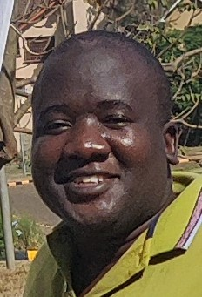

1. What is your background?

I have worked in mechanical engineering, more specifically generator maintenance, computer aided design and manufacturing. In addition, I have experience in Information Technology where I have been a systems developer.

1. How and when did you hear about ACLENet?

I was around in the early days of the founding. I participated in a quiz on lightning systems.

1. What motivated you to work with ACLENet?

I enjoy giving back to the community, and ACLENet's mission of improving lightning safety aligns with my desire to help others. Additionally, my background in mechanical engineering and information technology can be useful in technical site survey work and installations of lightning protection systems.

1. Please describe your work with ACLENet.

I assist in technical site survey work and installations of lightning protection systems. I also serve on the Lightning Protection Working Group and have searched out a number of local materials that we could use instead of expensive imported materials.

1. What are some of your key achievements so far with ACLENet?

I have acquired knowledge on lightning protection systems, which can help me be more effective in my work with ACLENet.

1. What are some of the challenges you have encountered in your work with ACLENet? How have you addressed these challenges?

In the course of my work with ACLENet, I have come across the challenge of dealing with misconceptions and myths surrounding lightning. To overcome this challenge, I have adopted a non-confrontational approach to educating local communities about lightning safety and protection systems, which has proven to be successful. By providing accurate information and correcting misconceptions, I am able to promote informed decision-making and help communities understand the importance of lightning safety.

1. How would you like to see ACLENet develop in the future?

I would like to see ACLENet continue to expand its reach and impact by partnering with more organizations and increasing awareness of the importance of lightning safety.

1. What do you see in the future for ACLENet regarding lightning safety?

In terms of the future of ACLENet and its efforts towards lightning safety, I envision more collaborations and partnerships with local organizations to engage professional engineers. By working together with these organizations and professionals, ACLENet can continue to expand its reach and impact, and help raise awareness about the importance of lightning protection systems.

1. Encouragement note

Keep up the excellent work and thank you for your contributions to fighting lightning deaths and injuries in Uganda.