Lightning Disaster led to closing of Maryland High School in Kitagata- Sheema District in 2013.
The School, Maryland High School, was located 20 kms from Ishaka-Bushenyi Municipality, in Bushenyi District. The story of the lightning incident was narrated by two brothers, Asiimwe Stephen and Kagorora Yorokamu. Both were directors of the school before it collapsed due to the disaster.
Mr. Asiimwe Stephen’s story:
By the time of the lightning incident, which killed three girls and injured 11 students, the school had an enrolment of 300 students. It was both day and boarding secondary school. After the disaster, many students changed to other schools leaving only 72 as the total school enrolment. This compelled the proprietors to close down the secondary school.

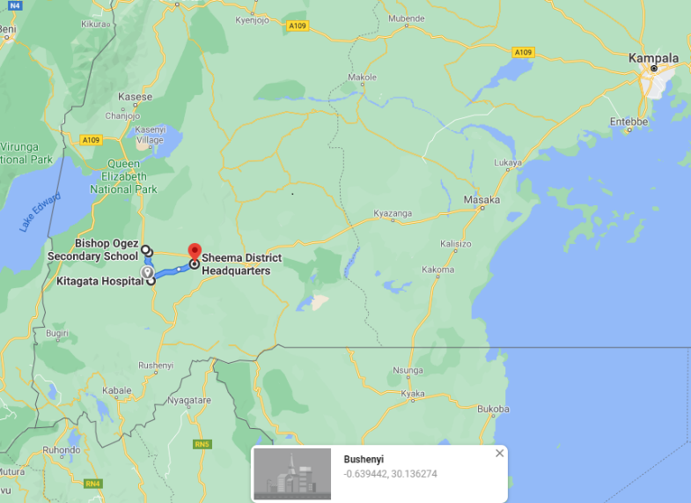
Lightning struck during first term, on 15th Jan, 2013 after a short drizzle, at around 12:30pm. The students were preparing to go for lunch. The victims who sustained the injuries were immediately rushed to Kitagata Regional Referral Hospital, 2Kms away from the school along Bugamba- Ishaka highway. “A good Samaritan,” Asaph Birukanga (RIP) offered his car to transport those who were injured. By God’s grace, all those that were injured, recovered but there was no proper follow up to establish whether there were side effects among the affected. This was because none of them returned to the school and it was quite difficult to trace their homes of origin.
Map of Southwestern Uganda showing some places mentioned in this lightning incident story
Kagorora Yorokamu, his brother, transported the 3 bodies to the mortuary at the same hospital. The lightning also struck one of the classroom blocks leaving the wall cracked.
Two of those who died were born from Kabwohe and Kitagata in the same district of Sheema, and the third was from Kabira sub-county in neighbouring Mitooma District.
Mr. Kagorora Yorokamu’s story;
He also expressed almost similar events his brother, Asiimwe Stephen, narrated in his story. He added that two of the girls who were struck dead were in form 3 and were not supposed to have been in the school at that time. It was only the new students of form 1 who had just reported that were supposed to be in the school. The form 3 girls who were illegally there, had gone to tease/bully the new students who they called “freshers.”
One of the deceased girls, Phionah, was a day scholar and a niece to Mr. Kagorora Yorokamu. She was staying with his family at his home 200metres away from the school. He (Mr. Kagorora) said that on that fateful day, he was at his home at about 12: 50p.m, when he saw students running towards his home and became suspicious. They were panting and looked quite scared.
One of them was courageous enough to break the unfortunate news to him when he inquired about the strange behaviour they had manifested before him. He immediately rushed to the school at the real scene, and found the victims lying down and put the three bodies in his car and took them to the hospital mortuary. Meanwhile, the injured victims were also being transported in Late Asaph Birukanga’s vehicles to the same destination.
To his dismay, he also said that on that fateful day lightning had struck and killed a teacher at Bishop Ogez Secondary School in Bushenyi district about 2 Kms from Ishaka-Bushenyi Municipality, almost 22km away from their school. The teacher was a brother to Mr. Longino Ishanga Ndyanabo, former Bushenyi District Chairman.
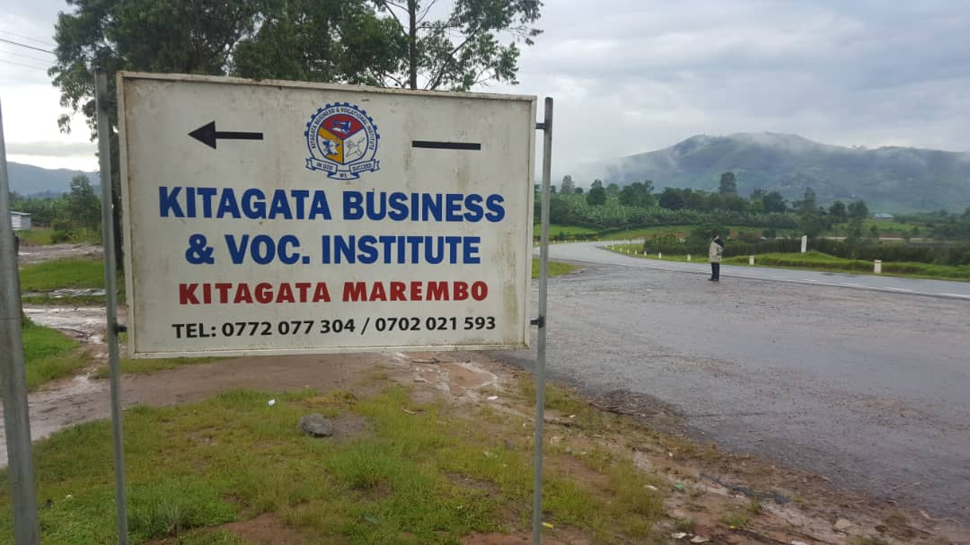
The high school (secondary school) was forced to close because of the mass exodus of students. The affected classrooms were pulled down and new ones erected in the same vicinity. However, enrolment failed to pick up. Presently there is a new institution of Kitagata Business and vocational Institute that replaced the Secondary School after its collapse.

PIC 1: sign post of the new institution

Myths/Misconceptions about the disaster.
It was alleged that most parents took away their children from the school because they associated the disaster to witchcraft. It was further alleged that the capital that was used to start the institution was from a source which did not please some people. The disgruntled group, according to the conspiracy theory, then used a witch who sent that bad omen (lightning) to destroy the investment. A head of laity from their Church, 100 meters away, tasked Mr. Asiimwe and Mr. Kagorora, to confess of their sins and pay back the “loot” to the grieved party if peace and sanctity were to be restored. The two gentlemen that were accused were innocent so they ignored the advice from the man of God.
It was also said by some people in the community that the school was located in an area vulnerable to lighting because it was not the first time such a thing was happening in the same place. The same year, lightning struck a nearby church, 100m away, killing the son of the reverend of that church. The boy was in Form 4 vacation. Unfortunately, when their results were released, he had emerged the best student in their school, Kyogyera Senior Secondary School in Sheema District.
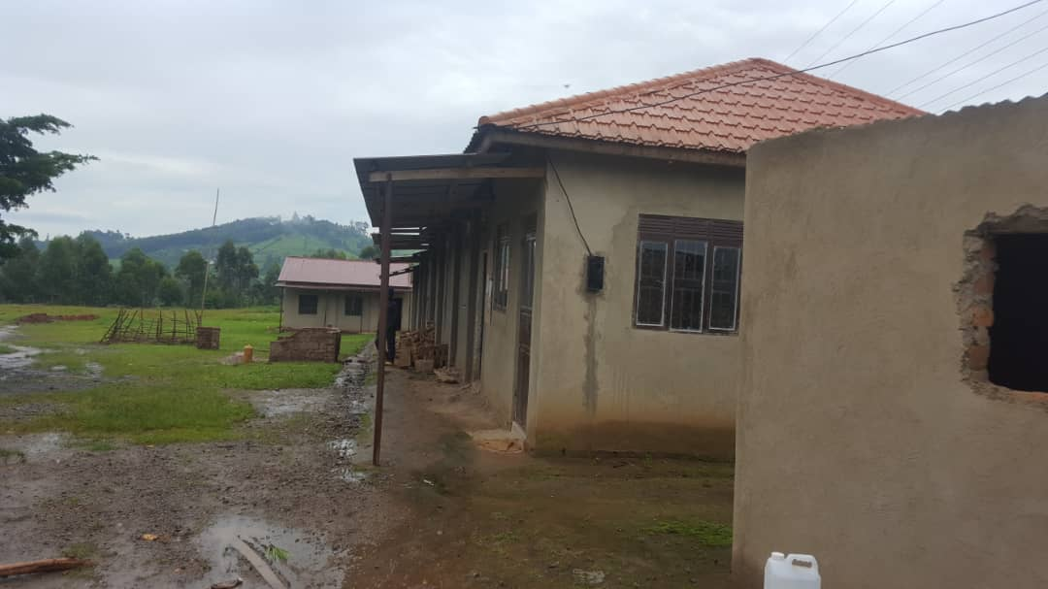
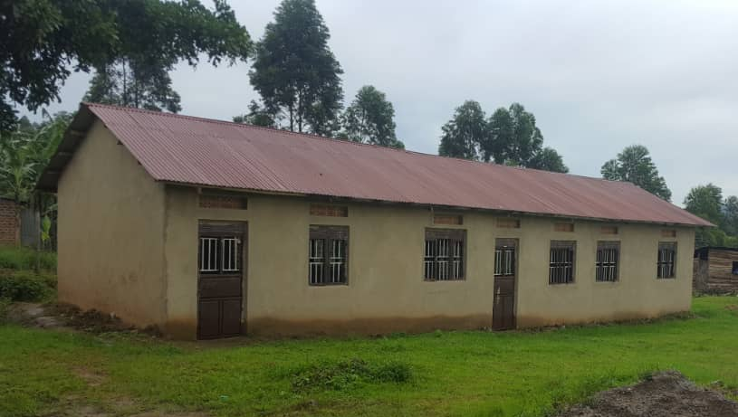
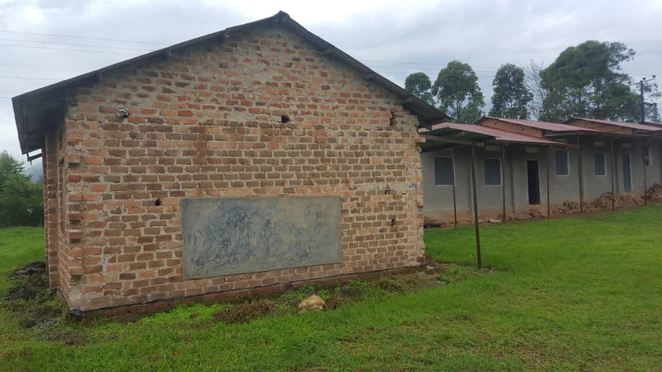
PIC 2: one of the newly erected classroom blocks PIC 3: administration block in the middle and a classroom block under reconstruction on right
PIC 5: classroom block where the destroyed building was attached (side view)
PIC 4: part of the classroom block that remained
(left side shows the wall that was attached to the classroom that was struck and destroyed by lightning).

