Lightning injures 30 students in Iganga (Uganda)
By Vision Reporter
Added 19th June 2015 08:05 PM
https://www.newvision.co.ug/new_vision/news/1328677/lightning-injures-students-iganga
ABOUT 30 students from St. Mathias Mawagala Secondary School survived death on Thursday, when they got struck by lightning following a heavy downpour.
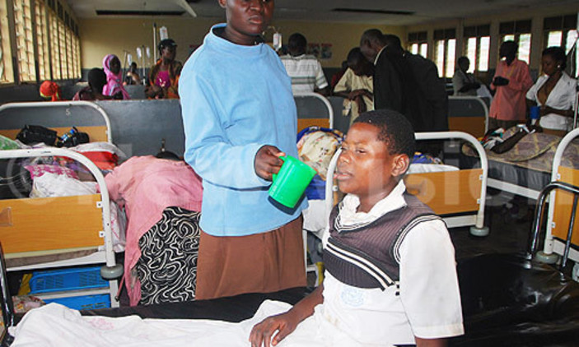
By Donald Kiirya
ABOUT 30 students from St. Mathias Mawagala Secondary School survived death on Thursday, when they got struck by lightning following a heavy downpour.
The incident happened at Nawaningi village in Nawaningi Sub-County in Iganga district.
According to the head teacher of St. Mathias, Esinweri Bazibu, lightning struck students during a heavy down pour at lunch hour.
Bazibu said after the incident, in the process of students yelling for help, he rang the Iganga Resident District Commissioner, Hajji Alamanzani Walugembe who sent his official vehicle to help ferry victims to Iganga hospital, Nakavule.
Some students were brought at the hospital using Boda boda motorcycles that were provided by good samaritans.
They were ushered into wards using stretchers and wheel chairs.
Shadiya Namuganza, one of the students of St. Mathias bedridden
The 30 students were assessed by health workers and are still under observation.
Bazibu added that victims complained of headaches and dizziness.
A number of students were also believed to be feeling numb in their limbs.
One of the students, Hajira Babirye, said that she heard a loud clap of thunder and some thing struck at once and she fell unconscious.
In hospital wards, victims were bedridden and others covered with mats for warmth. Other were put on drip.
Bazibu said that there are no lightning conductors at the school.
The Head Teacher of St. Mathias Mawagala Secondary School,Esinweri Bazibu
Residents at the hospital who included Mohammad Mulondo requested government to avail lightning arresters to private and public schools to reduce on such incidents.
Some of the injured students included Shadiya Namuganza, Sarah Kisakye, Hajira Babirye, Elizabeth Kawuma, Umar Waiswa, Josephine Kibadde and Julius Mugabo among others.
By press time, health workers were still attending to injured students.

