**Rwanda: Govt Urged to Expedite Acquisition of Lightning Rods.**

MAY 21, 2018

By Emmanuel Ntirenganya

<https://africareportonbusiness.com/2018/05/21/rwanda-govt-urged-to-expedite-acquisition-of-lightning-rods-2/>

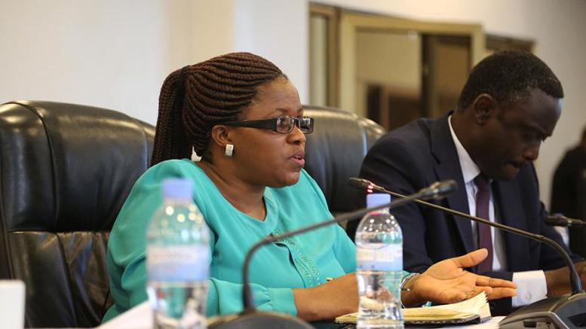

Members of Parliament have urged the Ministry of Disaster Management and Refugee Affairs (MIDIMAR) to fast track the procurement and installation of lightning rods or lightning conductors to avert the lightening induced deaths and other damages.

But, the target, which was due to be achieved in the 2017/2018 budget, was not attained because of procurement issues according to Jeanne d’Arc De Bonheur, the Minister of Disaster Management and Refugee affairs (MIDIMAR).

Addressing MPs during 2018/2019 budget hearing on Thursday, De Bonheur said that the lightning rods were not purchased on time because the ministry lacked timely qualified suppliers, and those who have capacities to install them.

She added that when the ministry got a business entity that could do that, it was late, and the funds that were allocated to the activity were about to be returned to the Ministry of Finance and Economic Planning (MINECOFIN).

As there were other emergency disaster cases to deal with, she said that the ministry decided to use the same funds help people who were affected by heavy rains.

“We requested MINECOFIN to allow us to use the money for the purchase of iron sheets to provide to families [whose residential houses were destroyed by heavy rains],” she said.

In the 2018/2019 financial year [which starts in July], she said, Government will spend Rwf300 million on lightning protection systems in 38 Sites in Rutsiro District, one of the districts where lightning cases are prevalent.

**Public spaces urged to get lightning protection systems**

A cabinet meeting that convened on May 2, 2018 to specifically discuss disaster management, resolved among other things that each public building should have a lightning conductor. Also, civil societies and churches have to install lightening conductors on their buildings, adding that the move will be inspected and reinforced.

De Bonheur said research showed that two lightning rods are sufficient for a trading centre and that traders will be encouraged or requested to partner and buy the lightning rods to install in trading centres in line with preventing lightning.

The Chairperson of the Standing Committee on National Budget and Patrimony, Constance MukayuhiRwaka, called on the private sector to enter the lightning rod business and ease people’s access to such equipment.

“Can’t we get an investor or a company can buy them in bulk so as to reduce the price?” she wondered, pointing out that MIDIMAR should coordinate the effort.

Lightning has hit various parts of Rwanda, killing people and injuring others according MIDIMAR. In March, lightning claimed lives of 16 worshipers when it struck Gihembe Seventh-day Adventist Church in Nyabimata Sector of Nyaruguru District.

From January to April 2018, lightning killed 36 people, injured 136 and also led to damage of livestock, houses and transmission lines according to figures from MIDIMAR.

In 2017/2018 financial year, MIDIMAR set a target of protecting people’s lives against lighting in 29 densely populated areas in Rutsiro District, an activity which was allocated Rwf200 million.

Fidèle Claude Kalimunda, a representative of ABB, a France-based company providing energy and automation technologies, a range of transformers, switchgear, circuit breakers, wiring devices among others told Sunday Times that there is need for a thorough study on lightning rods which can be suitable to a specific area in the country, and ensure quality rods that meet standards to ensure value for money.

“Lack of standard regulation measures and study on effectiveness on lightning protection system might end up in unnecessary costs on lightning rods, and loss of lives.

Research should be done to ensure that what is done is effective, protects people’s lives, and make sure that public funds are put to good use,” he said.