**Lightning strikes 28 cattle dead in Bali Nyonga-Cameroon**  
  
<https://mimimefoinfos.com/lightning-strikes-28-cattle-dead-in-bali-nyonga/>

23 June, 2024

[[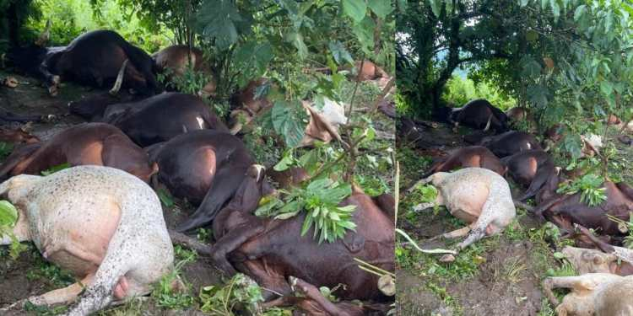](https://i0.wp.com/mimimefoinfos.com/wp-content/uploads/2024/06/IMG-20240622-WA0012.jpg?fit=1280%2C686&ssl=1)](https://i0.wp.com/mimimefoinfos.com/wp-content/uploads/2024/06/IMG-20240622-WA0012.jpg?fit=1280%2C686&ssl=1)

By Tata Mbunwe

A thunderbolt struck and killed 28 cows in Bali Nyonga, North West Region of Cameroon yesterday, devastating the Muslim cattle owners.

The cattle were grazing in Bossa village when the lightning strike occurred, leaving the animals dead.

Several non-Muslims rushed to the area to collect meat from the dead cattle. According to tradition, the Muslim owners refrain from consuming meat from animals that were not slaughtered by themselves, ensuring it meets their religious standards of purity.

The loss is a significant financial blow to the cattle owners, costing them several million francs CFA at a time when economic hardship and inflation are already taking a toll on Cameroonians.

The value of the livestock, alongside the immediate loss of income, compounds the difficulties faced by the herders.

Lightning strikes are not uncommon in Cameroon and have previously resulted in fatalities and significant damages.

In September last year, [Mimi Mefo Info reported](https://mimimefoinfos.com/cameroon-thunder-strikes-woman-and-daughter-to-death/) a lightning strike that killed a woman and her daughter in Magba, West Region.

In [another tragic event dating back to 2009](https://www.nbcnews.com/id/wbna32879345), a lightning strike in Bamali, North West Region, resulted in the deaths of five school children, with 34 others hospitalized.

Despite local beliefs associating lightning strikes with mystery and witchcraft, [scientists assert that these are natural occurrences](https://www.britannica.com/video/180139/lightning-thunder).

Lightning tends to strike people or objects that are exposed in open fields, leading to devastating consequences.