**Liberia: Lightning strikes 4 dead in Grand Cape Mount**

By [LPR Admin](https://liberiapublicradio.com/author/jggarley/)

June 8, 2020

<https://liberiapublicradio.com/2020/06/08/liberia-lightning-strikes-4-dead-in-grand-cape-mount/>

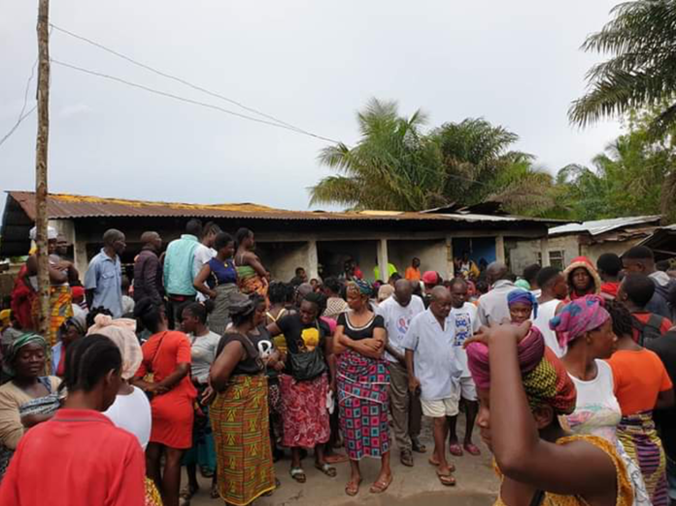

Family members and sympathizers at the scene of the thunderstorm [photo: Front Page Africa]

By*Garmah Lomoh|LPR News, Monrovia*

**Report from Grand Cape Mount County says five persons have been killed by lighten in two separate communities in the area.**

According to the report, On June 5, 2020, a 17 year old girl identified as Mamie Tufa 7th grade student who came Sierra Leone to spend time with her relative in mageema town, Porkpa District due to lockdown was strike dead by the lightening.

The report added that the victim Mamie Tufa was sitting in the front poach of their house pealing eggplant to cook evening food when a 21 year old man identified as Semilah Kemokai came to visit her.

The report further says, when they were sitting at the front poach of their house, victim Mamie had touch screen phone and gave it to Semilah for holding when the lightening firstly strike her dead and later killed the boy.

Prior to the lighten killing Mamie, she informed her friends that she was threatened by a lady for man business in Sierra Leone.

**Everything that she ever touched for that day, the lighten affected all.**

While, in Bombojah community Commonwealth District, nine persons were affected by the lightening but three instantly died on June 5, 2020.

Those who met their demise were an old ma and two little boys.

All the nine person were sitting on their front poaches of their house when the lighten strike and killed the three persons while the remaining six including pregnant woman got severely wounded.

The dead included a grandmother Ma Juma 68 year old, Haruna Fahnbulleh a male, 9, Juma Kromah female 4years of age. One person Bendu Kromah, aged 5 survived

Meanwhile, the survivors are currently receiving treatment at a local clinic in the area while, the pregnant woman was transferred to the Sinjeh Health Center due to her condition.

In another development, violent storm has destroyed several homes in Tewor district on Friday night June 5, 2020.