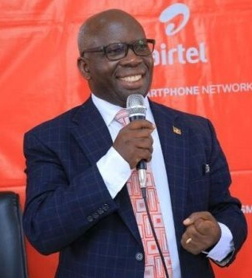

HERO of the MONTH
July 2023

Charles Tonny Mukasa Lusambu

- What is your background?
I'm a teacher by profession, who has gone through several ladders of education and profession. I have also climbed many levels in education leadership, right from classroom teacher, Deputy Headteacher, Headteacher, District Education Officer, Assistant Commissioner and Commissioner for Primary Education in the Ministry of Education and Sports. I am now a retired Commissioner, doing Consultany work on Educational Matters. I'm a co- Founder Director of: Mivule Primary Schools and Ndere Troupe, a cultural Performing (Musical) Group in Kampala.

- How and when did you hear about ACLENet
I got to know about ACLENet when I worked in the MoES as Commissioner in charge of allocating lightning arresters to schools in Uganda.

- What motivated you to work with ACLENet?
I was motivated to work with ACLENet after realizing that they were involved in providing Scientific awareness on lightning as well as safety and protection against lightening hazards. Noting that lightning mostly strikes vulnerable, poverty striken, remote areas in our country. I always feel for the vulnerable!

- Please describe your work with ACLENet.
I serve as a Resident Director for ACLENet in Uganda, now for about one year. I attend the BOD meetings, monitor the ACLENet installations, lobby for more members to join our ACLENet Lightning Safety Team. I also do my best to coordinate Government organs with ACLENet.

- What are some of your key achievements so far with ACLENet?
We have achieved the MoU between ACLENet and OPM, achieved a cordial working relationship between ACLENet and Hon. Onek's Office, in charge of Disasters in the country. Together with my team in Uganda, we hosted our President and co-founder of ACLENet last year. I have monitored some ACLENet LP installations in the country. I am currently involved in working out a MoU between Kiryandongo District and ACLENet. Together with the Uganda Team, we are planning to establish a Lightning Awareness Museum and training center at Runyanya Primary School, the site of the disaster in 2011 when eighteen children were killed by one lightning strike.

- What are some of the challenges you have encountered in your work with ACLENet? How have you addressed these challenges.
Working with some Government Officials on social services like lightning safety is a big challenge, where they don't expect allowances and other handouts. I therefore avoid some of them and identify those with a human heart and move along with those.

- How would you like to see ACLENet develop in the future?
I would like ACLENet to:
(a) Be the icon for lightning awareness and safety in Africa and beyond. e.g. The intended museum at Runyanya should act as the African Centre for Lightning Safety and Awareness, Research etc.
(b) I wish ACLENet could have capacity to protect all schools in the lightning corridor of Uganda.

- What do you see in the future for ACLENet regarding lightning safety?
(a) I see ACLENet mobilising a big team of different people joining our Lightning Safety Team in Uganda.
(b) I see ACLENet pioneering the move to let Uganda embrace the International Standard of Lightning Protectors.

- Encouragement note
"Genuine happiness is not necessarily in how happy you can be as an individual, but in how many people can be happy because of you."

- Is there anything else you would like to include – personal information, family, goals, etc? Is it ok to list your email?
It's o.k.to list my email - Charles Tonny Mukasa Lusambu <lusambuless@gmail.com>

Compiled by Dr. Charles Tony Mukasa Lusambu.

