Nyagatare: Inka 12 n’intama ebyiri zakubiswe n’inkuba - Rwanda
Yanditswe na
EMMANUEL GASANA SEBASAZA
https://www.kigalitoday.com/umutekano/imbere-mu-gihugu/article/nyagatare-inka-12-n-intama-ebyiri-zakubiswe-n-inkuba
30-11-2021 - 20:37' | Ibitekerezo ( 1 )

ENGLISH SUMMARY by Citizen Reporter Frank Shumbusho, Tct Tct <tct2020@gmail.com>
The lightning strike of yesterday, Tuesday 30 November 2021, killed twelve Cows and two Sheeps, belonging to Mr Sam Ruzindana. This tragedy occurred in Rubira Village, Rutungu Cell, Rwimiyaga Sector, Nyagatare District, within the Eastern Province of Rwanda. Mr Sam Gatunge, the Executive Secretary of Rwimiyaga Sector, confirmed this sad news.

Kuri uyu wa Kabiri tariki ya 30 Ugushyingo 2021, inkuba yakubise inka 12 n’intama ebyiri z’uwitwa Rugamba Emmanuel wo mu mudugudu wa Rubira akagari ka Rutungo umurenge wa Rwimiyaga akarere ka Nyagatare.
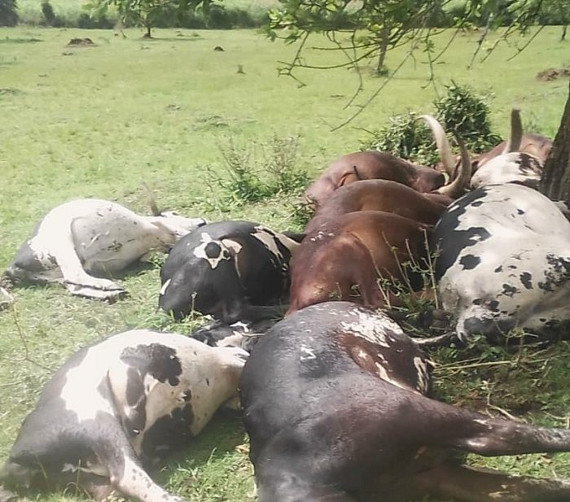
Inka zakubiswe n’inkuba mu mvura nyinshi ubwo zari mu rwuri rwazo
Ibi byabaye mu mvura yaguye ahagana mu masaa saba z’amanywa ubwo inka zari mu rwuri rwazo ndetse n’intama, mu nka 30 ikubitamo 12 hasigara umunani.
Rugamba avuga ko mu nka zakubiswe harimo amajigija ndetse n’izaraye zibyaye, ikindi ngo nta bwishingizi bwazo yari afite.
Umunyamabanga nshingwabikorwa w’umurenge wa Rwimiyaga, Gatunge Sam avuga ko ubuyobozi buzajya kumusura ngo harebwe ko hari icyo yafashwa.
Uwo muyobozi agira inama aborozi gufatira amatungo ubwishingizi kugira ngo bubagoboke mu gihe bahuye n’ibibazo.
Ati “Navuganye n’ubuyobozi bw’akarere turajya kumusura kuri uyu wa Gatatu ubwo ni ho hazafatirwa umwanzuro w’icyo yafashwa. Ariko turongera kwibutsa aborozi gufatira amatungo yabo ubwishingizi kuko uretse inkuba yaje itunguranye ariko n’inkurikizi cyangwa indi ndwara yakwica amatungo yabo.”

