FRANK SHUMBUSHO – Citizen Reporter from Rwanda since 2015
- Featured in 2023-01 newsletter

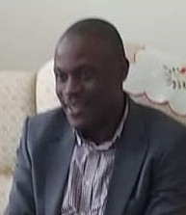
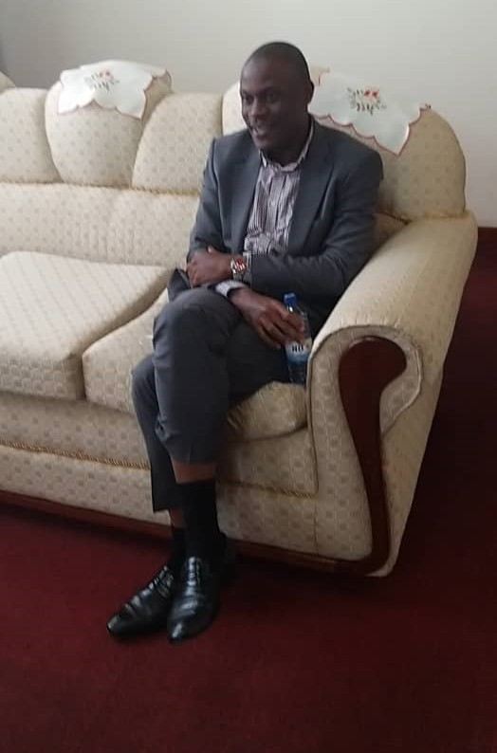
- What is your background or education?
My education is more of an informal one, having attended different courses with general background. I am almost self-taught by the exposure I have had from different experiences.
- What are your motivations to the study of lightning safety?
My motivation remains saving lives through the humanitarian rescue programs.
- What motivated you to work with ACLENet?
Awareness and more scientific technical interventions
- How and when did you hear about ACLENet?
I got to know through the internet in mid-2015
- Kindly describe your contribution/work with ACLENet?
Reporting general events related to lightning injuries and deaths
- What are some of your key achievements so far with ACLENet?
Awareness and networking
- What are some of the major challenges you have encountered along?
Less of practical interventions mostly in relation to the preventive measures which is what is needed especially within developing countries.
- What do you think can be done to the encountered challenges?
Resources mobilization
- What do you see in the future for ACLENet regarding the study of lightning safety?
More cooperation with the concerned Governments, NGOs and Academia
- What areas of improvement would you want to see with ACLENet in the field of lightning safety?
Move from mainly organizing the academic related international conferences, more into the ground work within the most affected countries.
- Encouragement note
To all of you folks keep doing what you are doing especially since I understand most of you are doing it on volunteer basis.
I thank you all

