'I feel like a T-Rex': Couple survives after lightning strikes their car [South Africa]
2019-10-01 06:16
Jenni Evans
https://www.news24.com/SouthAfrica/News/i-feel-like-a-t-rex-couple-survives-after-lightning-strikes-their-car-20191001
Christine and Wynand Van der Merwe (Supplied)
A young couple had an electrifying experience on their way to Sunday lunch after their car was struck by lightning.
"When it hit, it was like all blank for me almost," said Wynand van der Merwe on Monday.
The product developer and his graphic artist wife were on their way to have a family lunch with their sister visiting from abroad at The Hut in Moorreesburg when lightning struck as they were about to reach the Western Cape town.
"There was the hit, and then moments later my eyes opened and everything was white," Van der Merwe continued.
"The car was like a dead ant moving slowly forward from the momentum. I'm like 'OK, I don't know what just happened'," he said.
People who had been driving behind them told them lightning had hit their car's aerial and said they had expected to find the couple dead inside the car.
"They said to us, 'You were just struck by lightning'."
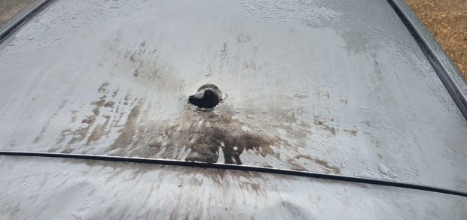
The roof of the Van der Merwes' car where the aerial was before lightning struck (Supplied)
A person in the vehicle behind them called his parents who were driving ahead of them and they turned around to fetch them. They removed the vehicle's battery just in case the car caught fire, and later continued their journey to a restaurant in Moorreesburg for a family lunch.
He downed a strong hot chocolate after spilling the first one they had bought at the last stop before finishing their journey during the strike.
At the time he and his wife, Christine, considered themselves unscathed.
However, when he woke up on Monday his arms felt sore and seemed swollen.
He could not stretch them out comfortably so he went to see a doctor.
His doctor said it might be muscle damage due to electric shockwaves, but he is running some tests to be safe and to check for kidney damage.
"I feel like a T-Rex - I can't really reach anything," he laughed, referring to the short-armed dinosaur.
He added he was glad they included "Act of God" to their insurance package, so the damage to the 2011 vehicle would be covered.
"My life hasn't been easy for my guardian angel," he chuckled.
In the meantime, social media posts in drought-stricken areas showed some rain had fallen in parts of the Western Cape on Sunday.
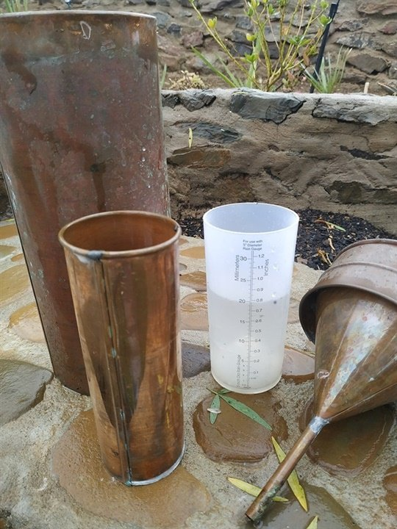
Rain in the Klein Karoo (Supplied by Andrew Sokolic)
The Western Cape government said the average dam levels in the province were currently 66.1% (2018: 65.7%).
"Over the past weekend, some much-needed and very welcome rain showers hit the drought-stricken Karoo region of the province," said a statement on behalf of Local Government MEC Anton Bredell.
The level of the Gouritz catchment area was, however, at a low 18.52% in spite of warnings of extreme weather.
The City of Cape Town said it had not received reports yet of weather-related disasters.

