Households given lightning rods as KZN launches summer disaster awareness campaign in Nongoma
POSTED OCTOBER 19, 2018 COGTA_USR
http://www.kzncogta.gov.za/households-given-lightning-rods-as-kzn-launches-summer-disaster-awareness-campaign-in-nongoma/
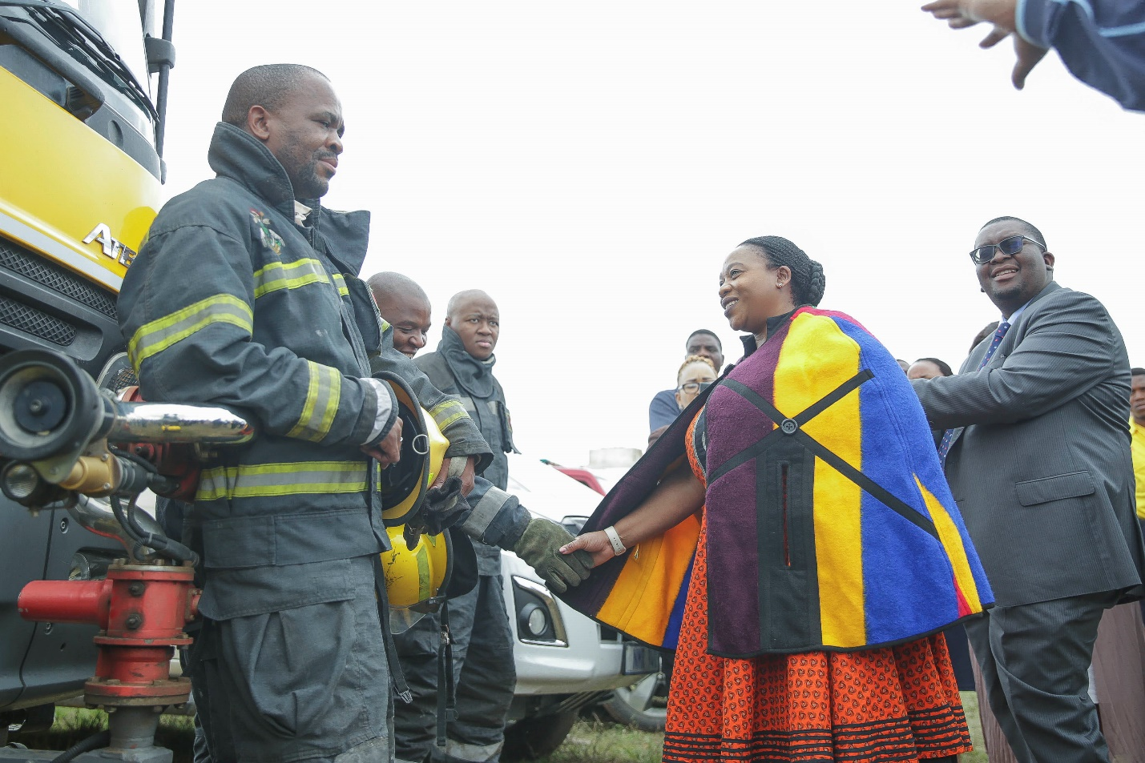
As part of KZN’s measures to deal with disasters, the Department of Cooperative Governance and Traditional Affairs (Cogta) under the leadership of MEC Nomusa Dube-Ncube today handed out lightning conductors to households in Nongoma. This initiative will ensure that people are protected from lightning strikes which are common in rural areas where they leave a trail of death and destruction in their wake.
Speaking to thousands of community members from the areas of ekuBungazeleni, Esiphambanweni, Moscow, Bambelentulo, Sibonelo, eDushwini, Cabokwakhe, Nkabane, Kombuzi and Hlanzeni in Nongoma who had come to attend the Provincial Summer Disater Awareness launch at the ekuBangazeleni Sports Grounds, Dube-Ncube urged communities to exercise caution when there are heavy rains, lightning and thunder.
“Our province is regularly battered with heavy winds coupled with rains that cause localised flooding. This causes death and destruction costing millions of rand which could go towards accelerating service delivery in our communities. Our gathering here with you as the community of ward 20 is to ensure that no more lives are lost to incidents that occur during the summer season,” said Dube-Ncube.
During the launch, Dube-Ncube revealed measures that her department has implemented in order to lessen the negative impact of disasters. These include dispatching disaster teams, equipment and resources to various parts of the province as part of beefing-up of the provincial capability to deal with disasters.
Dube-Ncube also announced various service delivery interventions that are planned in partnership with the Department of Social Development, Human Settlements and the Provincial Treasury which will see families receiving RDP houses under the existing Operation Sukuma Sakhe programme.

