Lightning strike kills 15-year-old as torrential rain batters Musanze - Rwanda
https://www.newtimes.co.rw/article/8527/news/environment/lightning-kills-15-year-old-torrential-rains-damage-11-houses-in-musanze
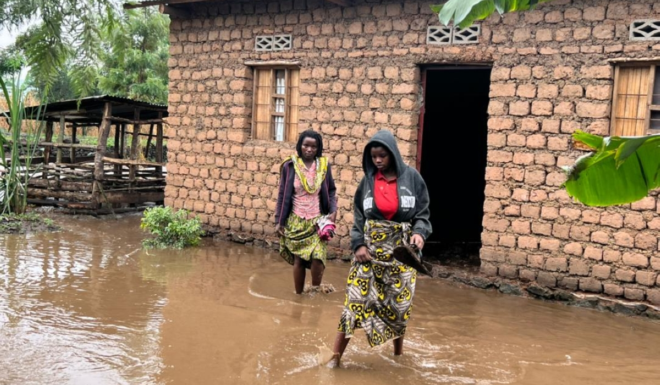
Residents wade through a flooded residentials area after the torrential rains that damaged 11 houses in Musanze District on Friday, June 23. Photo: RBA
Emmanuel Ntirenganya
Saturday, June 24, 2023
Torrential rains on the night of June 23 damaged 11 houses - with one completely destroyed - while lightning killed a 15-year-old boy in Musanze District, Mayor Janvier Ramuli told The New Times.
The Mayor said there was heavy rainfall in Kinigi Sector. Water flowed along the drainage system which was under construction in order to address the issue of torrential rains that cause damage to residents and their property.
The drain passes through Cyuve Sector and Gacaca Sector, Ramuli said. It was being constructed in line with the Government's initiative to contain destructive flood water that flows from the Volcanoes National Park.
He pointed out that the torrential rainwater reached an area of the drain that was not yet constructed and spilled over into residents' houses in Gacaca Sector, indicating that it flooded 11 houses of which one was completely destroyed.
Also, he said, some domestic equipment in the affected houses were damaged, "but no human life was lost in that sector”.
The rain water killed a buffalo calf, washing it away from the Volcanoes National Park into Muhoza Sector, Cyabararika Cell.
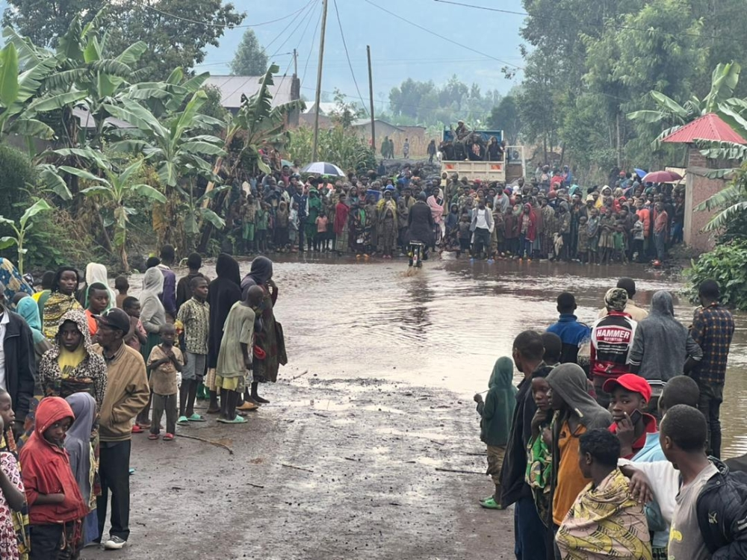
Residents turn up to see the damages that were caused by rains
Meanwhile, he noted that there was a lightning strike in Nyange Sector, killing a 15-year old called Tuyubahe, and damaging a power transformer, which disrupted electricity supply to some households.
"The number of damaged cash power [electricity supply meters] were still being counted," he said.
"We are going to rent accommodation for the 11 families whose houses were damaged while waiting for the water to be removed so that the houses are renovated.”
The affected people will also get basic needs such as food, beddings, and hygiene equipment through the partnership with the Ministry of Emergency Management.
Residents from the area who spoke to Rwanda Broadcasting Agency (RBA), said that the moving of people has been impeded by floods and that there was a need to expand the drain to be able to contain large amounts of water.
Ramuli said that in partnership with the Rwanda Water Resources Board, efforts are going to be put into constructing the drain in question so that it gets expanded and completed to ensure smooth water flow and prevent destructive spillover.
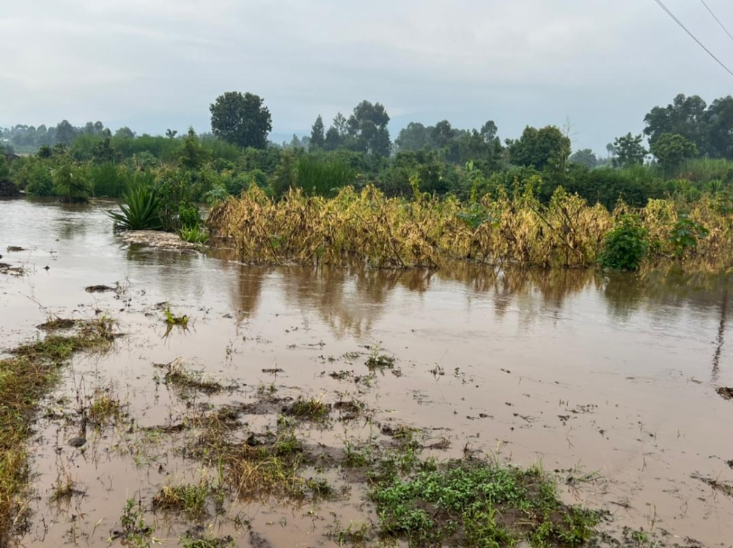
A view of a flooded farm in Musanze. Water flowed along the drainage system which was under construction in order to address the issue of torrential rains that cause damage to residents and their property.
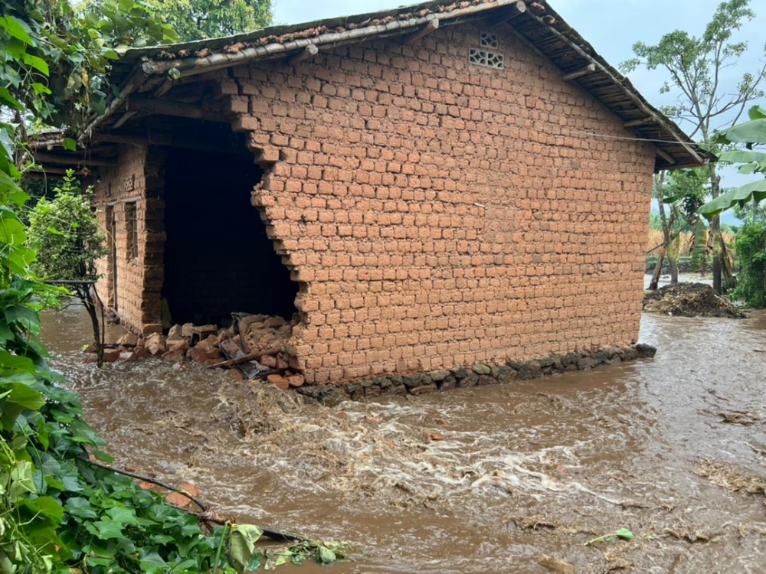
One of the 11 houses that were damaged by heavy rains in Musanze District on June 23.

