Mother, class 8 daughter, Form 3 son killed in lightning strike (Kenya)
https://www.capitalfm.co.ke/news/2018/03/mother-class-8-daughter-form-3-son-killed-lightning-strike/
March 3, 2018 (4 days ago) 8:53 am
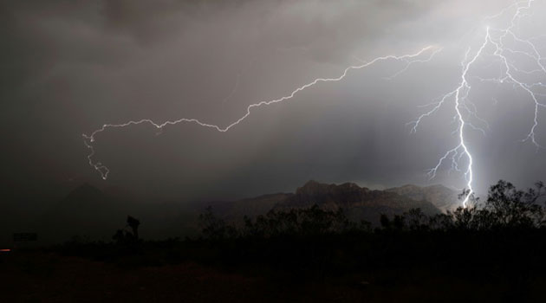The family was seeking shelter from the rain when they were struck dead by lightning/FILE
By CORRESPONDENT, NAIROBI, Kenya, Mar 3 – A mother and her two teenage children were on Friday night killed after being struck by lightning at Kamujwa Tunyai village Tharaka south sub county.
Makena Gatundu together with her two children, son (form three) and daughter (class 8) we’re struck dead by lightning at around 8pm while seeking shelter from the rain that pounded the area.
Residents said they informed police who were yet to collect the bodies by 11pm.

