‘I shouted for her to come out of the house’ - Zuma's niece survives Nkandla lightning strike
Nathi Olifant | 25 January, 2017 18:53

http://www.timeslive.co.za/local/2017/01/25/%E2%80%98I-shouted-for-her-to-come-out-of-the-house%E2%80%99-Zumas-niece-survives-Nkandla-lightning-strike

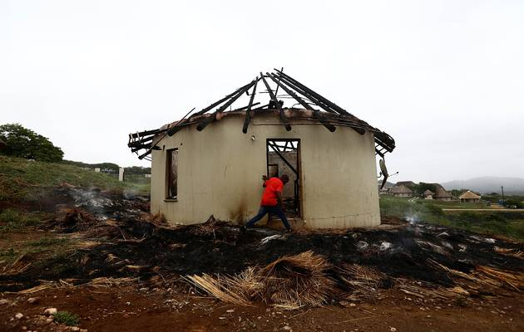
The smouldering remains of Mabuyi Zuma’s thatched rondavel 24 hours after being razed by a lightning strike. Image by: THULI DLAMINI

President Jacob Zuma's niece‚ Mabuyi‚ is grateful that she escaped unharmed from her burning rondavel after it was struck by lightning in Nkandla‚ a stone’s throw away from the president's homestead.
Mabuyi‚ who was with a seven-year-old child in the thatched rondavel‚ lost everything‚ including identity documents‚ birth certificates‚ bank cards and furniture in the fire during a fierce storm on Tuesday afternoon.
The rondavel was still smouldering when The Times arrived almost 24 hours after the incident.
Mabuyi‚ 43‚ was still shaken by the incident. She had sought refuge inside the two-room rondavel as a thunderstorm intensified over Nkandla on Tuesday.
Little did she know that‚ just minutes later‚ her place of apparent safety would almost become a death trap.
"The storm gathered quickly and there was a lot of lightning. I went inside to unplug the TV and other appliances. But a minute later there were red and yellow flames all around. I took out the child and cellphones and ran out‚" she said.
A relative‚ Hlebe Zuma‚ who was in one of the other five nearby rondavels‚ said a big streak of lightning struck Mabuyi's house like a rock falling from the sky.
"I shouted for her to come out of the house. The flames were instant‚" he said.
Her daughter had to go to school on Wednesday without shoes and part of her uniform.
"This has saddened me because everything that was inside was expensive stuff bought over the years‚" she said.
Her father‚ Khanya‚ Zuma's younger brother‚ said they had informed the president. Attempts to get comment from the presidency were unsuccessful on Wednesday.
Fire engines from Umlalazi (eShowe) and Nkandla Municipalities arrived almost two hours after the lightning strike.
Umlalazi and Nkandla fall under King Cetshwayo District Municipality‚ formerly known as uThungulu District on the KwaZulu-Natal north coast. Newly-elected Ward 14 councillor Bongokwakhe Mbambo said the torched house was part of the Zuma family homestead in the KwaNxamalala village.
"Everything was destroyed‚ they lost everything but‚ luckily‚ no one was injured‚" said Mbambo.
Mbambo said four other houses were destroyed during the thunderstorm‚ including one that collapsed and another that was blown away.
The Nkandla area is prone to lightning strikes during summer.
-TMG Digital/The Times

