**Rutsiro: Lightning-induced deaths decline in public places – official - Rwanda**

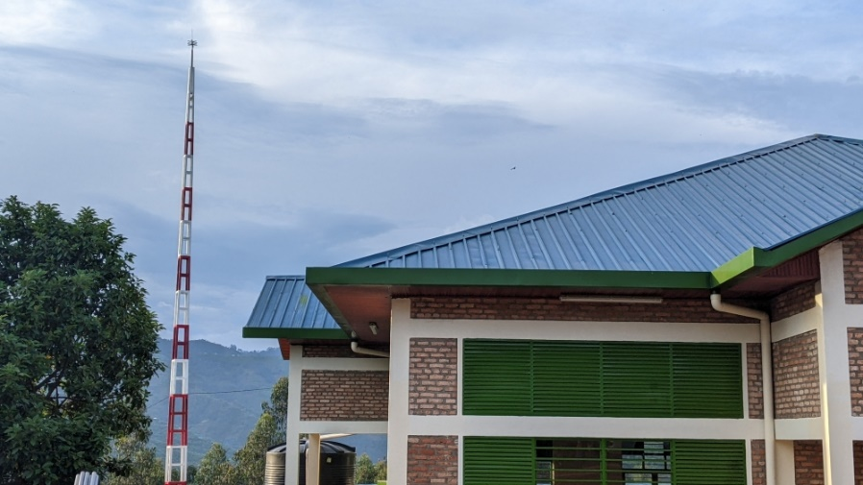

Lightning-induced deaths declined in public places in Rutsiro District/ Photos by Germain Nsanzimana

[Germain Nsanzimana](https://www.newtimes.co.rw/author/66/germain-nsanzimana)  
Friday, May 31, 2024

Rutsiro district authorities have registered a significant decline in lighting-related deaths following the installation of thunderbolts in public places.

Rutsiro is one of the seven districts of Western Province where risks of disasters are high, according to the Ministry in Charge of Emergency Management (MINEMA).

ALSO READ: [Western Province put on alert over climate resilience](https://www.newtimes.co.rw/article/16042/news/environment/disasters-western-province-put-on-alert-over-climate-resilience)

As part of ongoing initiatives to build disaster resilience in the district, about 161 lighting rods were installed in 129 buildings under the support of the ministry, Emmanuel Uwizeyimana, the Vice Mayor in charge of economic development, told *The New Times.*

He also noted that 12 other lighting rods (Active Control AF2000TT) were also installed in schools under the district stakeholder’s support.

According to him, the thunderbolts contributed to the decrease of deaths by lighting in public places.

"We conducted an assessment from all public places; churches, schools, public buildings, in particular. All schools are protected from lightning by thunderbolts. All of the thunderbolts we installed are of high cost which ordinary residents cannot afford,” he noted, without revealing the cost.

“That is why we work with REG (Rwanda Energy Group) when they're connecting homes; there is an alternative they use which should help in prevention of lighting. If you look at recent times, we’re not having a lot of cases of lighting in public places. It is clear that such cases now happen mainly in households.”

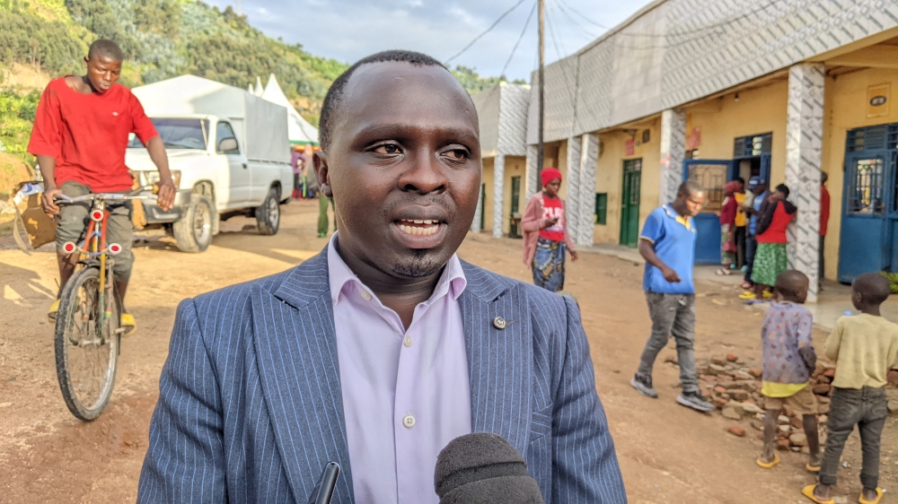

⁠The Vice Mayor responsible for Economic Development for Rutsiro district, Emmanuel Uwizeyimana.

An earthing system is the cheapest preventive measure commonly used at home. It uses an earth rod buried underground and connected to a meter. The whole installation can cost nearly Rwf10,000. Some people, however, often do not use them, thereby putting their buildings, life and belongings at risk.

As regards to how vulnerable people should prevent thunderstorms, Uwizeyimana said the district keeps mobilizing its population for different practical measures to reduce lighting risks.

"We continue mobilizing people so that they should not wander outside when it's raining, not use umbrellas and plug electric devices like mobile phones. This is what we continue to do for our population, to help them learn how to prevent lighting," he added.

According to Adalbert Rukebanuka, the Director General of Planning, Policy, and Risk Reduction at the ministry, 492 disaster-related deaths were recorded over the past five years. These included 317 deaths that occurred due to thunderstorms in Western Province.

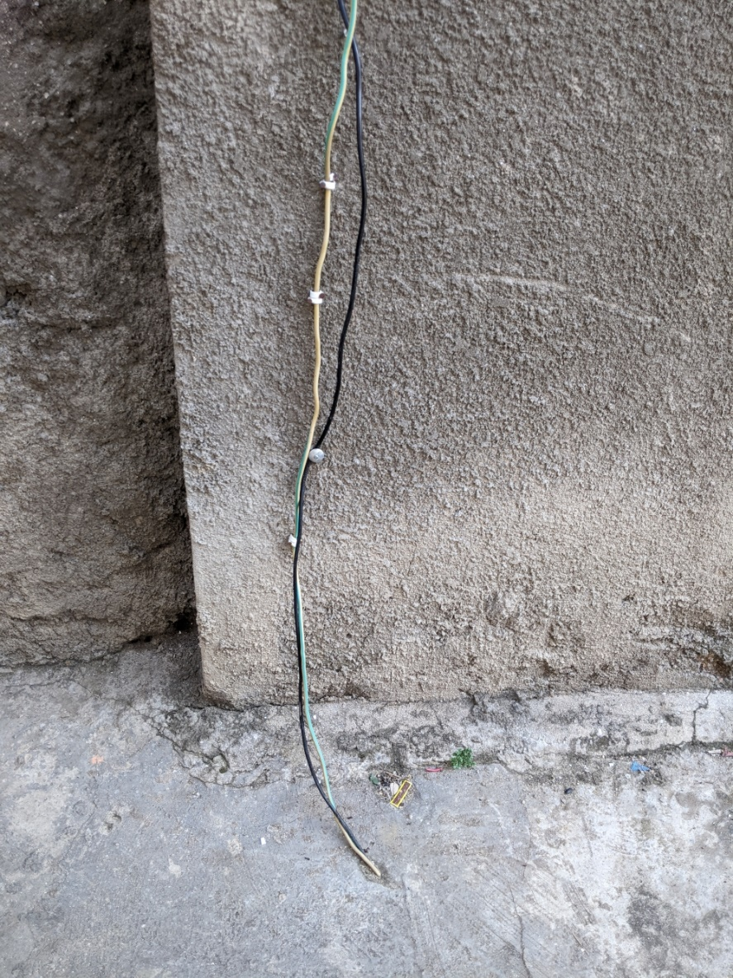

⁠Earthing system commonly used at home.