HERO of the MONTH
December 2023
Isaac Tumuhimbise
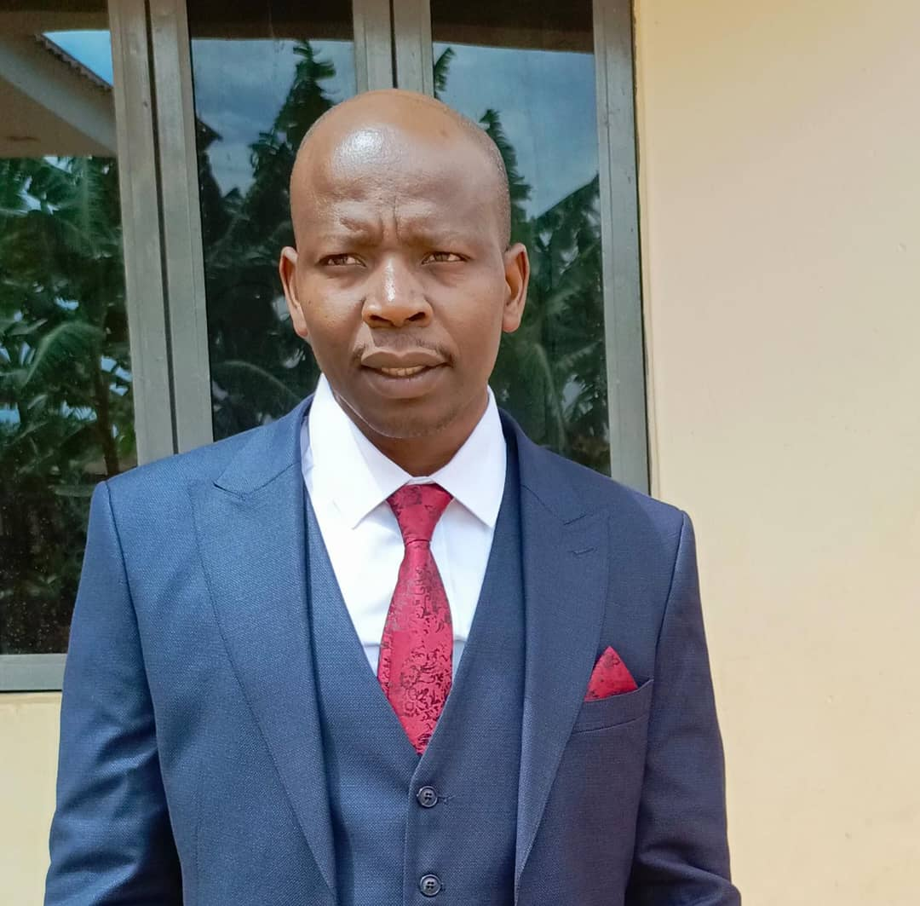
- What is your background?
- My name is Tumuhimbise Isaac, a male Ugandan, 32 years old, certified electrical technician by Electricity Regulatory Authority (ERA) Since 2012, I attained certificate part two, certificate part three in electrical installation and National diploma in electrical engineering at Uganda military engineering collage-Lugazi Kampala-Uganda. Since I graduated 2011, I worked with many organizations like Almo Engineering company as certified electrician, Umeme as assistant technical officer, Ministry of water and environment, southwestern umbrella as electromechanical technician and ACLENet as Chief Lightning Protection Systems installer since 2016 up today.

- How and when did you hear about ACLENet?
- I heard about ACLENet in 2016 after incident of lightning at Buramba primary school, through Mr. Tushemereirwe Richard, one of the directors of Aclenet.

- What motivated you to work with ACLENet?
- Saving the lives of Ugandans from lightning strikes
- Working in a team and leading one in Africa.
- Good designs and installations of lightning protective systems

- Please describe your work with ACLENet.
- Chief LPS installer ACLENet;
- installing and maintaining lightning protection equipment.

- What are some of your key achievements so far with ACLENet?
- Working on ACLENet’s Lightning Protection Working Group to design and advise on local conditions in Uganda and at the schools that the team might not be familiar with.
- Training for and completing lightning modules with LPC-South Africa.
- Participated in ICLP2022 at Cape Town in south Africa
- Installed all schools in Uganda protected by ACLENet
- Participated to design masts that installed at Mongoyo primary school northern Uganda

- What are some of the challenges you have encountered in your work with ACLENet? How have you addressed these challenges.
- One of the challenges is the means of transport, mostly Chief LPS installer moving with tools in public means.
- Lack of laptop but management is working on it.

- How would you like to see ACLENet develop in the future?
- Installing all schools in East Africa

- What do you see in the future for ACLENet regarding lightning safety?
- Educating all Africans about lightning

- Encouragement notes
- I’m so proud of ACLENet

- Is there anything else you would like to include – personal information, family, goals, etc? Is it ok to list your email?
- Am married, with three kids and I love my field
Contacts: +256700198628 / +256785605315
Email: tumuhimbiseisaac2016@gmail.com

