7 Cows Killed by Lightning in Ndengo Sector of Rwanda
09 November 2022
https://mobile.igihe.com/amakuru/u-rwanda/article/kayonza-inkuba-yishe-inka-zirindwi-z-umuturage

Yesterday,9th November 2022,lightning struck and immediately killed seven cows in Ndengo Sector, Kayonza District, within the Eastern Province of Rwanda.
Mr Claude Bizimana, the Executive Secretary of Ndego Sector, confirmed the reporting of this tragedy.

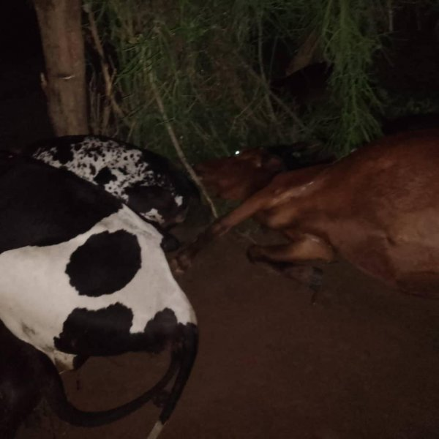

Kayonza: Inkuba yishe inka zirindwi z’umuturage
10-11-2022 - saa 09:44, Hakizimana Jean Paul
https://mobile.igihe.com/amakuru/u-rwanda/article/kayonza-inkuba-yishe-inka-zirindwi-z-umuturage
Inkuba yakubise inka zirindwi z’umuturage wo mu Karere ka Kayonza mu Murenge wa Ndego, zihita zipfa.
Ibi byabaye ku mugoroba wo kuri uyu wa Gatatu tariki ya 9 Ugushyingo 2022.
Umunyamabanga Nshingwabikorwa w’Umurenge wa Ndego, Bizimana Claude, yabwiye IGIHE ko nyiri izi nka yari atunze izisaga 20. Ubwo ngo hagwaga akavura gake ku mugoroba, haziyemo n’inkuba ikubita zirindwi zihita zipfa.
Ati "Inkuba yakubisemo inka zirindwi zihita zipfa ako kanya, ubu tugiye kuzitaba kuko nta kindi twakora."
Yaboneyeho gusaba aborozi gufata ubwishingizi bw’amatungo yabo kuko budahenze, ndetse Leta yemeye gushyiramo nkunganire.
Ati "Urumva uriya muturage nta bwishingizi yari afite, ubu rero turasaba abaturage gufata ubwishingizi, ibyago ntabwo biteguza kandi ubwishingizi bw’amatungo burimo nkunganire ya Leta. Ku babufite rero mu gihe habaye ibyago nk’ibi ng’ibi baba bizeye ko bari bugurirwe inka zabo."
Hashize iminsi mu Ntara y’Iburasirazuba hagwa imvura nke irimo inkuba, zakunze kwibasira amatungo.
Ingero za vuba ni inka eshanu ziherutse gukubitwa n’inkuba mu Karere ka Nyagatare. Mbere yaho nabwo inkuba yakubise izindi zirindwi z’umuturage.

-----
Report by email from Frank Shumbusho at tct2020@gmail.com.

