Lightning kills 17 goats at farm Regina (Namibia)

News - National | 2018-02-11

https://www.namibian.com.na/64258/read/Lightning-kills-17-goats-at-farm-Regina

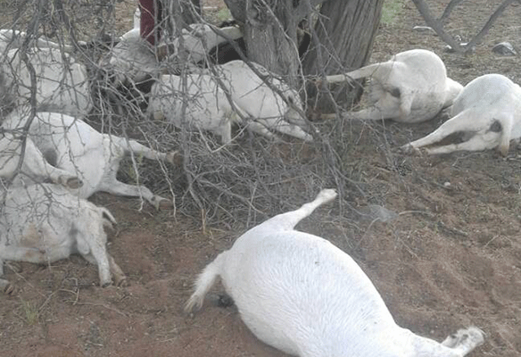
MIXED FEELINGS ... Seventeen goats were killed on Thursday by lightning on farm Regina near Helmeringhausen in the //Karas region.

KEETMANSHOOP – Rain is always welcome in the hot and dry //Karas region, but this natural phenomenon sometimes brings with it troubles and loss to farmers and residents alike.
A strong bout of the late rains of the current season caused one such farmer, Abraham Thomas, to lose a sizeable amount of his livestock at farm Regina, situated four kilometres outside Helmeringhausen in the Bethanie district.
Lightning killed 17 of Thomas' goats at around 17h00 on Thursday.
Thomas told Nampa that he recorded between 20mm and 40mm of rain on that day and it was during this downpour that his 17 goats were struck by the lightning.
“One was a stud ram and 15 were in the last stages of their gestation period,” said Thomas.
He said the same thing happened to him in November last year when the rainy season began.
In this instance, one his of cattle perished after being struck by lightning.
“It is part of the farming business, it is part of the risks that come with farming,” the farmer noted philosophically about his loss.
According to Thomas, so far, the area received close to 178mm of rain, with two more months to go before the season ends.
– Nampa

