Lightning kills 2 teachers, injures 20 pupils in Buyende, Buikwe - Uganda
By Jackie Nambogga
Added 5th March 2020 01:00 PM
https://www.newvision.co.ug/new_vision/news/1516017/lightning-kills-teachers-injures-pupils-buyende-buikwe
Richard Waiswa, a parent who rushed to the school, said most of the affected pupils were of Primary Three-Six, who shared the same classroom block.
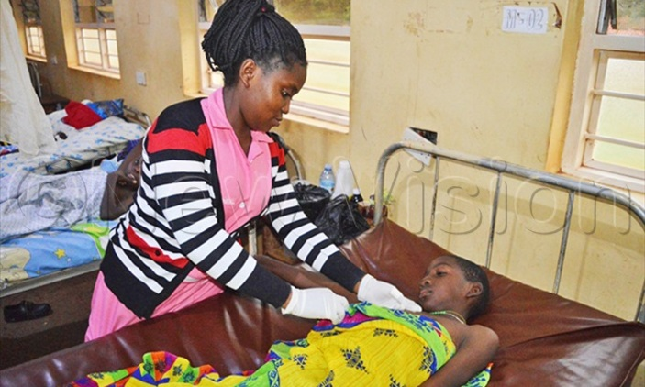
A health worker examining one of the injured pupils of Modern Primary School Ssenyi. Photo by Jackie Nambogga

A teacher and school bursar have been struck dead by lightning at Queen Zainab Inuula Primary School in Bugaya sub-county, Budiope East county in Buyende district.

The 4:50pm incident which occurred on Wednesday during a heavy downpour also left two other teachers and seven learners injured.

The Buyende district education officer, Dison Bwire, confirmed the incident which claimed Mathias Wandyaka, the school bursar and Barbara Birungi, a Primary Three class teacher.

According to Salim Tembuli, a teacher who witnessed the incident, the heavy rains began at 3:00pm and as they neared stopping at about 4:50pm, the lightning struck.

Tembuli said it occurred as teachers were giving homework to the learners in their respective classes.

Richard Waiswa, a parent who rushed to the school, said most of the affected pupils were of Primary Three-Six, who shared the same classroom block.

Whereas some of the Government primary schools have lightning arrestors, Bwire said this was not the same with all the private primary schools in the area, including Queen Zainab.

Of the 91 government primary schools, Bwire said 26 have lightning arrestors.
He said the schools that have been equipped with the arrestors were the new ones constructed under the School Facilitation Grant (SFG) programme.

Buikwe thunder
Similarly, seven pupils of Modern Primary School Ssenyi located at Ssenyi landing site in Ssi sub-county, Buikwe district were also admitted at various health units after being struck by lightning.

Those who were admitted at St. Charles Lwanga Hospital, included Sylvia Nalugera, Owen Kisiga, Joyce Babirye, and Gift Nanfuuna, all in Primary Six.

Others are Sheira Namusisi, 14 of Primary Seven while Hariida Kisaakye Hariida,10 and Ian Bogere were of Primary Five.

Whereas the Luuka thunder was characterised with heavy rains, Namusisi, one of the injured learners in Buikwe, explained that it was raining lightly.

She explained that as the lightning started striking, their teachers stopped teaching and retreated to the back of the classroom and instructed them to remain silent.

Shortly, they saw ‘rays of fire’ striking into their classes and took cover under their desks, only to gain consciousness while in hospital.

Jane Frances Kagaayi, the Buikwe resident district commissioner, attributed the incident to a lack of lightning arrestors, with few trees at the school compound.

Kagaayi said long trees help to track lightning, which schools in the area should grow as a measure of arresting such situations.

Kagaayi, together with the Lugazi municipality mayor, Deo Tumweisgye Mbabazi, urged headteachers and school proprietors to embrace the education ministry’s policy of installing lightning arrestors.

According to Julius Kizito Musasizi, the Buikwe district education officer, of the 200 primary private schools, only five are equipped with thunder arrestors.

Musasizi added that out of the 73 government primary schools, only 30 were equipped.

